AUTOMATION TESTING ON YOUR LOGO-SHOPPING WEBSITE

NAME: ATCHAYA.M

BATCH CODE: 2021-5218

REVIEWED BY: PRIYANKA DESLE

COURSE : SCHOOL OF CODING - CERTIFIED SOFTWARE TEST ENGINEER BY EDUBRIDGE

**Introduction**

This Project aims to do overall testing like functional testing, GUI testing on website to check quality of application. It helps to improve quality of website and saves time for manually doing this testing. In this project our main focus is to check functionalities available on website. Also, it includes title check and all links count with their working status.

**Software Requirements Operating System :-**

* Window 10 Browser
* Latest version of Google Chrome IDE
* Eclipse IDE Front-end
* Java & Selenium webdriver

**TC01- Launch the browser and open Website**

System.*setProperty*("webdriver.chrome.driver", "C:\\Users\\atcha\\OneDrive\\Desktop\\Selenium_Jar\\chromedriver.exe");

WebDriver w=**new** ChromeDriver();

w.get("http://automationpractice.com/index.php");

**TC02- To test the functionality of “Get Savings”**

w.findElement(By.*className*("img-responsive")).click();

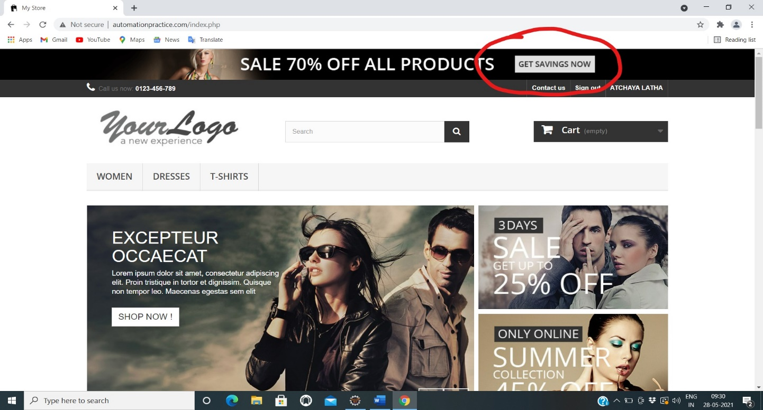

**TC03 To test the functionality of “Contact Us”**

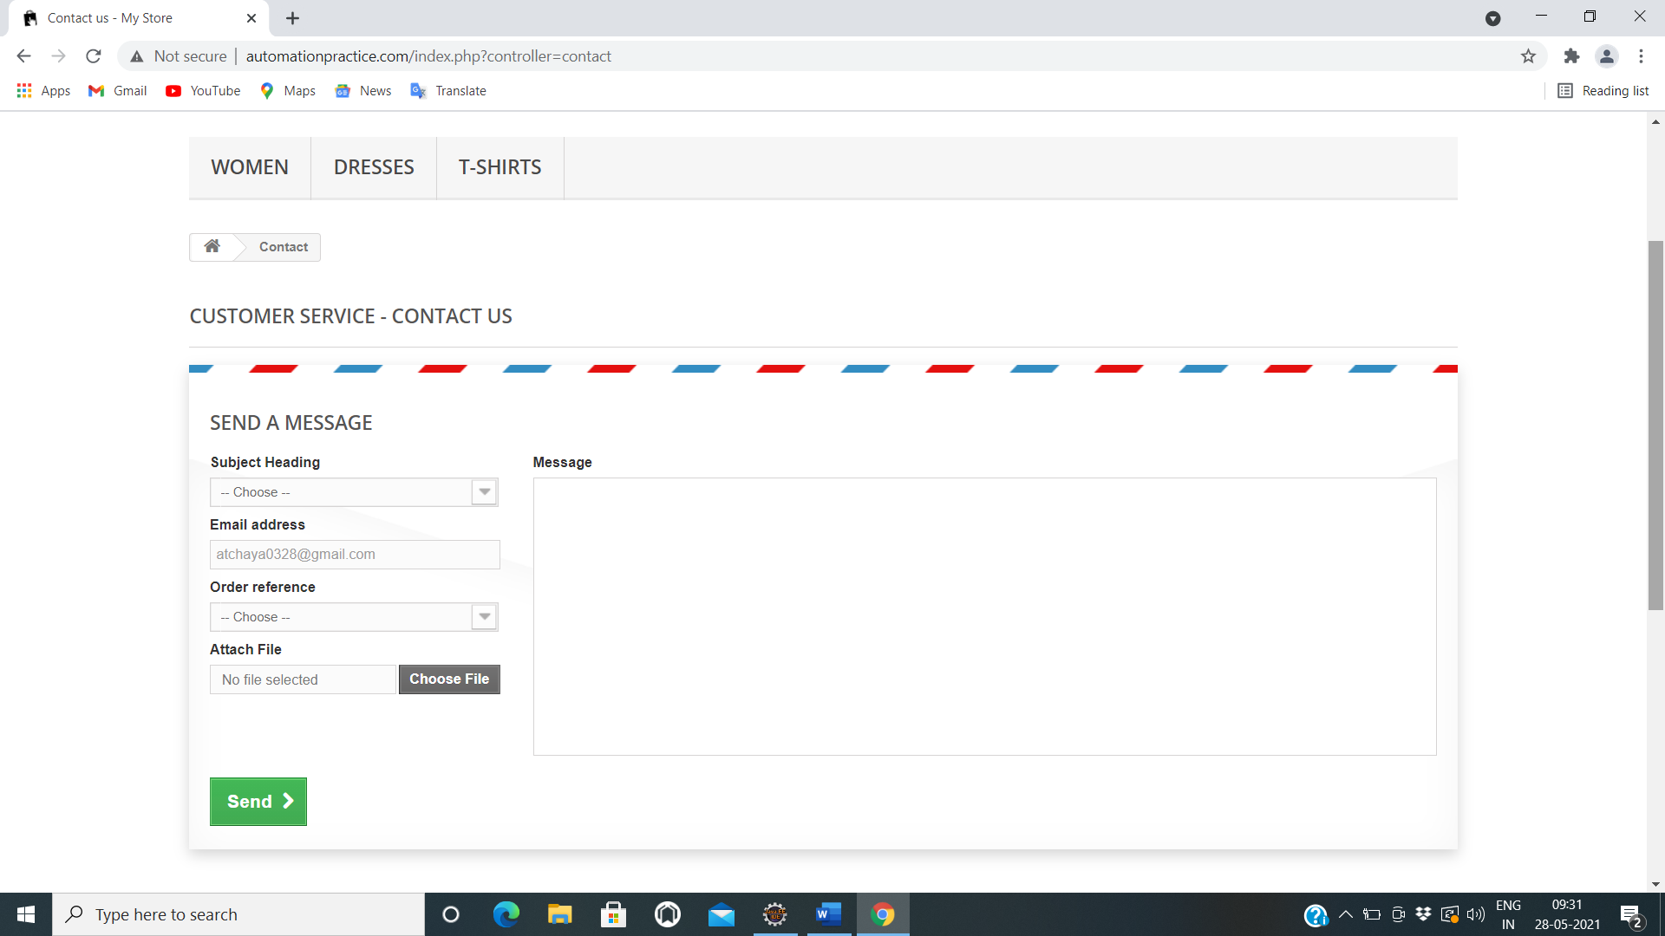

a1.selectByValue("1");

w.findElement(By.*id*("email")).sendKeys("atchaya17@gmail.com");

w.findElement(By.*id*("id_order")).sendKeys("AT0328");

w.findElement(By.*id*("fileUpload")).sendKeys("C:/Users/atcha/Downloads/Atchaya.pdf");

w.findElement(By.*id*("message")).sendKeys("Defective Product Received");

w.findElement(By.*id*("submitMessage")).click();

**TC04 To test the functionality of “Sign-In”**

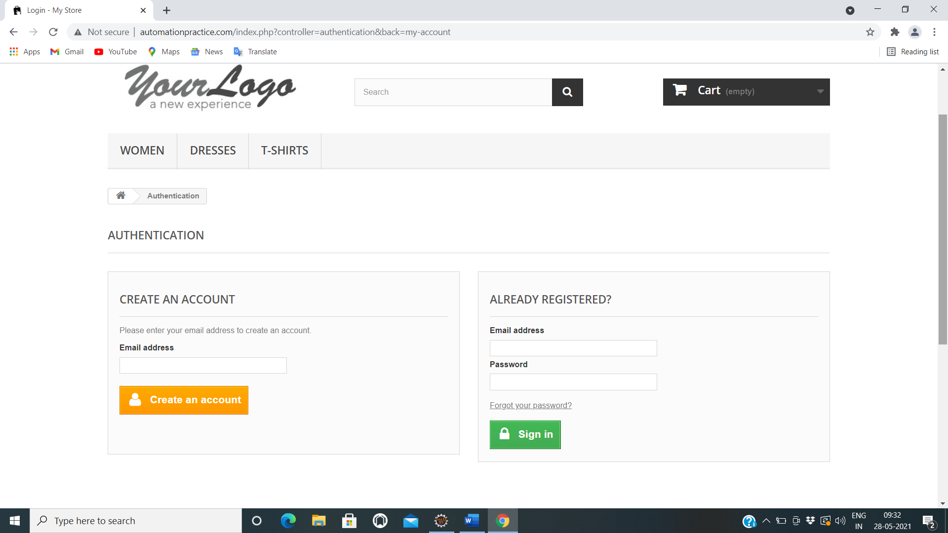

w.findElement(By.*xpath*("//a[contains(text(),'Sign in')]")).click();

w.findElement(By.*id*("email_create")).sendKeys("atchaya17@gmail.com");

w.findElement(By.*name*("SubmitCreate")).click();

**TC05 To test the functionality of “Create an Account”**

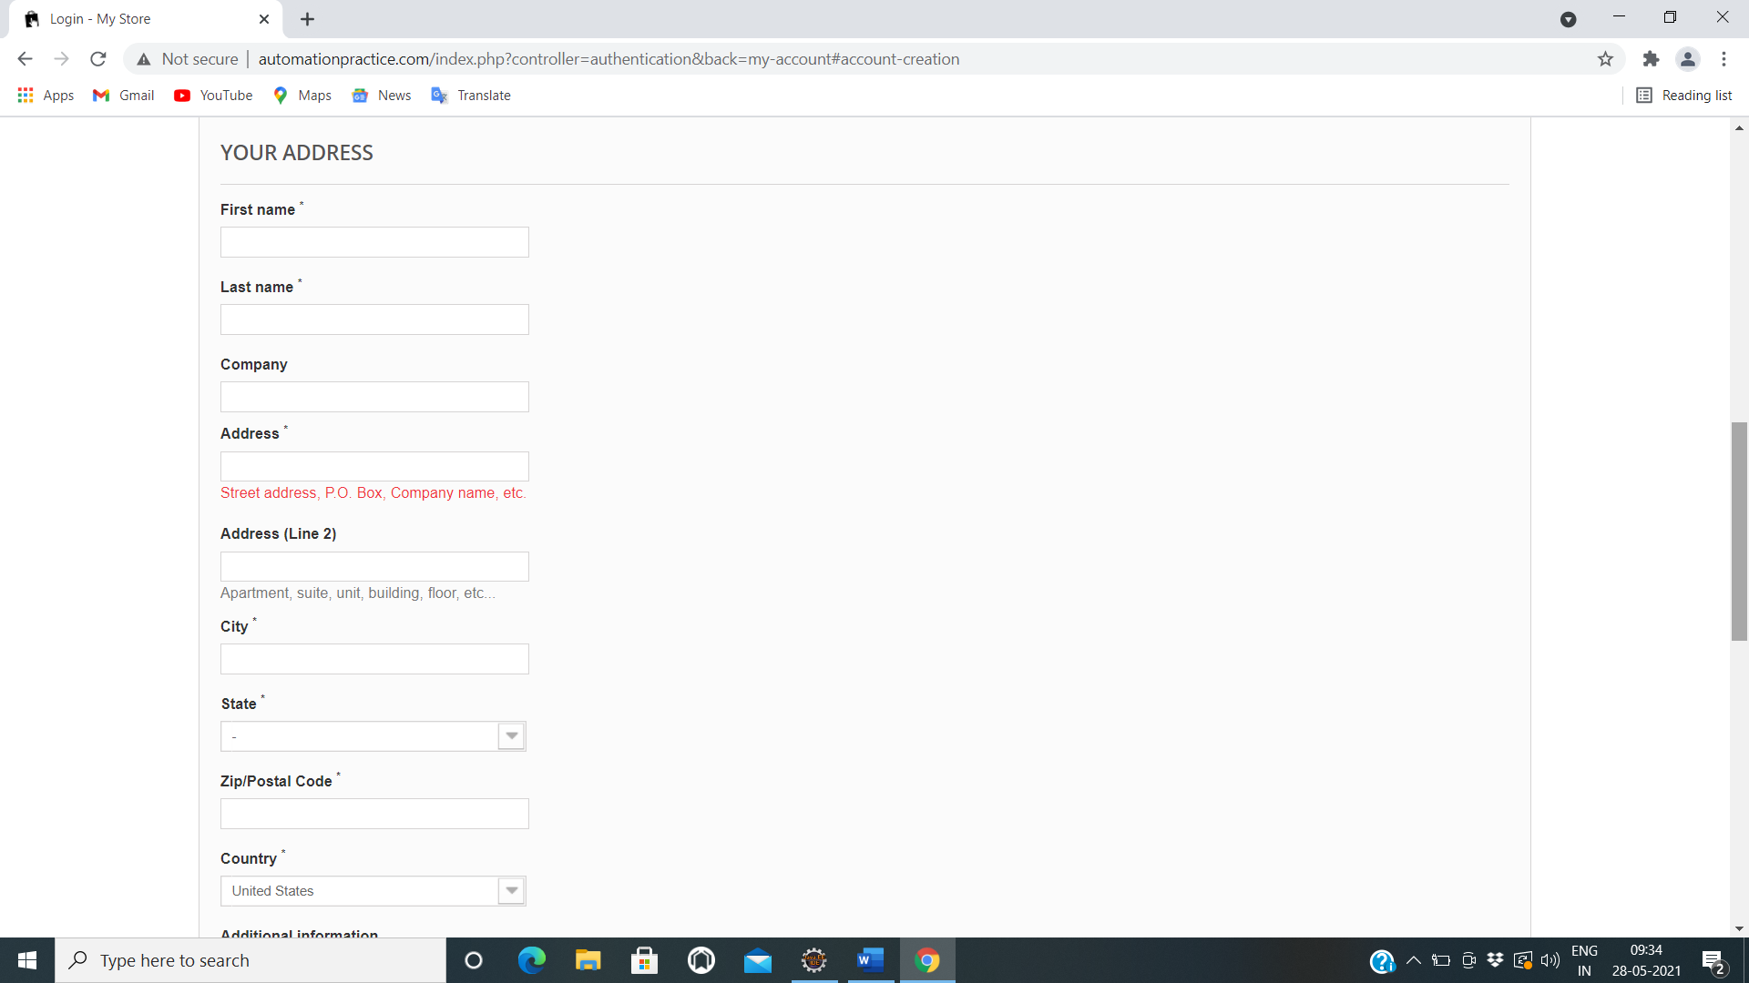 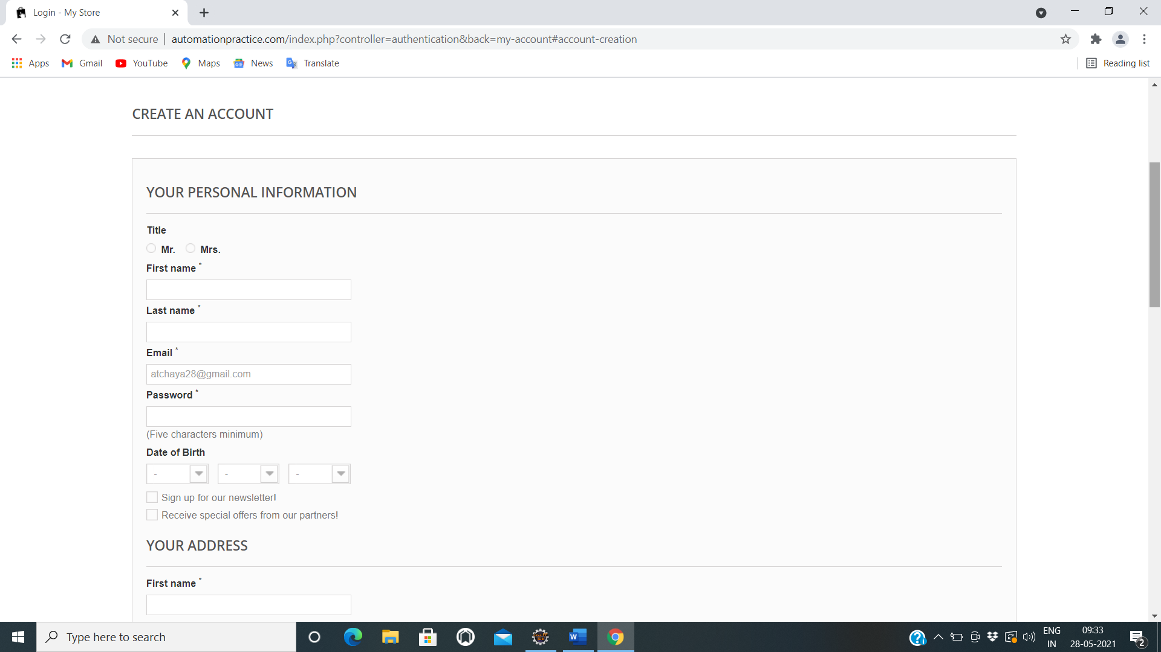

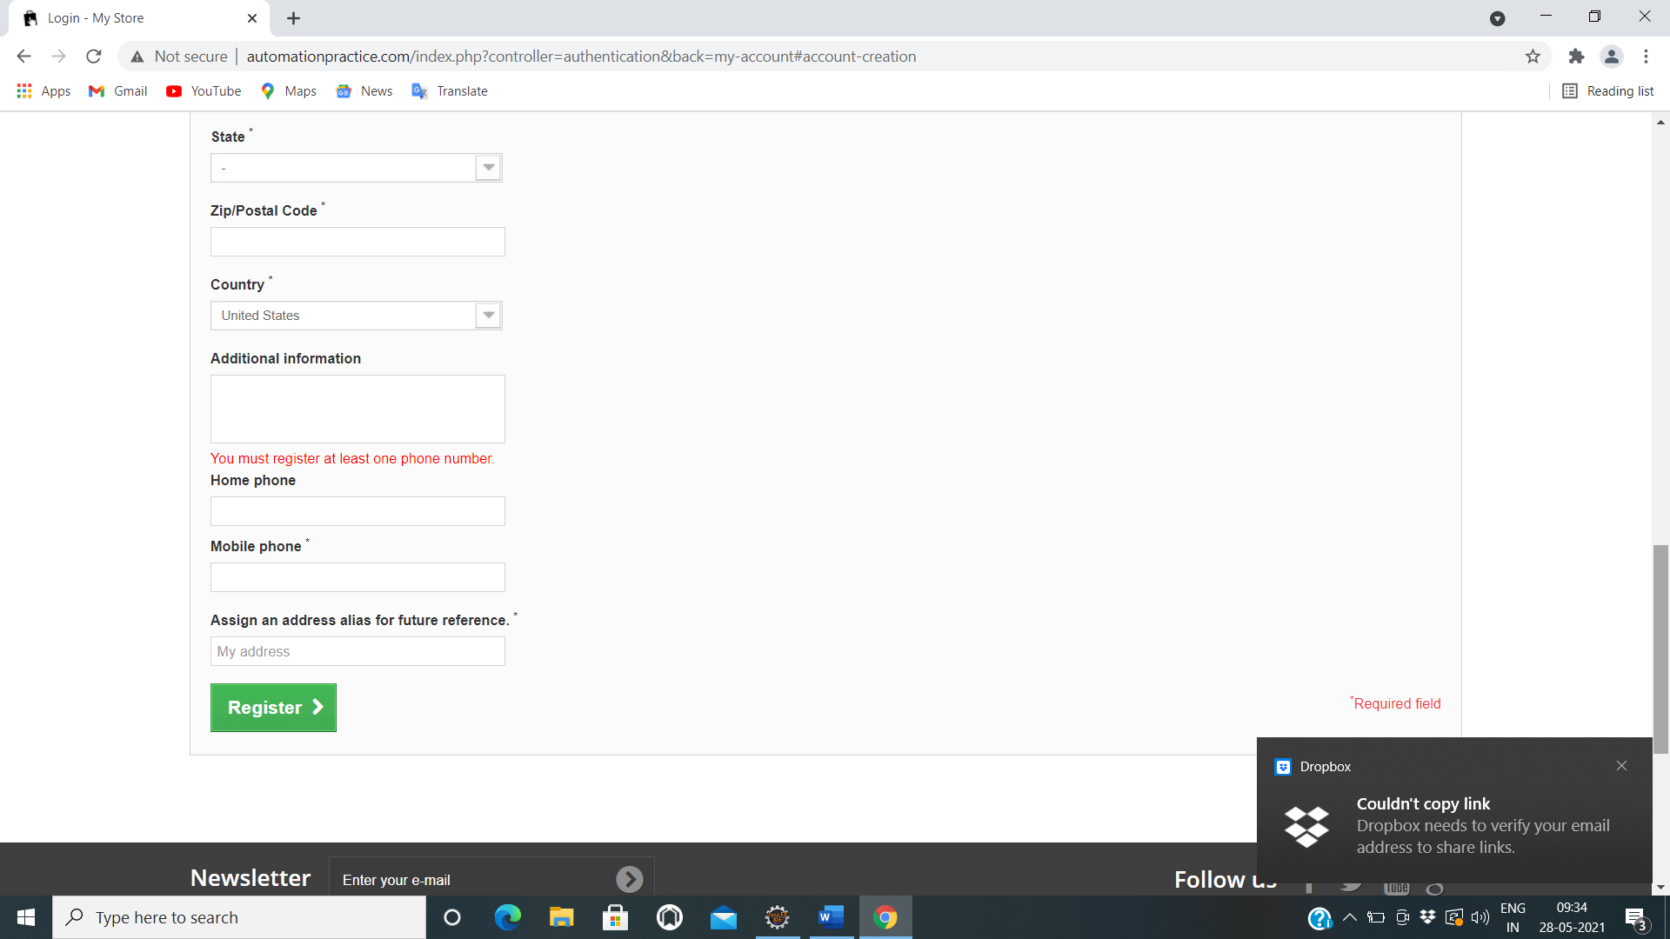

Thread.*sleep*(5000);

w.findElement(By.*id*("id_gender2")).click();

w.findElement(By.*id*("customer_firstname")).sendKeys("ATCHAYA");

w.findElement(By.*id*("customer_lastname")).sendKeys("LATHA")

w.findElement(By.*id*("passwd")).sendKeys("Atchu@08")

Select a3=**new** Select(w.findElement(By.*id*("days")));

a3.selectByValue("28");

Select a4=**new** Select(w.findElement(By.*id*("months")));

a4.selectByValue("10");

Select a5=**new** Select(w.findElement(By.*id*("years")));

a5.selectByValue("1997");

w.findElement(By.*id*("newsletter")).click();

w.findElement(By.*id*("optin")).click();

w.findElement(By.*id*("firstname")).sendKeys("Atchaya");

w.findElement(By.*id*("lastname")).sendKeys("Latha");

w.findElement(By.*id*("company")).sendKeys("Capgemini");

w.findElement(By.*id*("address1")).sendKeys("xyz");

w.findElement(By.*id*("address2")).sendKeys("abc");

w.findElement(By.*id*("city")).sendKeys("kumbakonam");

Select a6=**new** Select(w.findElement(By.*id*("id_state")));

a6.selectByValue("14");

w.findElement(By.*id*("postcode")).sendKeys("00000");

Select a7=**new** Select(w.findElement(By.*id*("id_country")));

a7.selectByValue("21");

w.findElement(By.*id*("other")).sendKeys("Nill");

w.findElement(By.*id*("phone")).sendKeys("8220190545");

w.findElement(By.*id*("phone_mobile")).sendKeys("8248934920");

w.findElement(By.*id*("alias")).sendKeys("abcd");

w.findElement(By.*id*("submitAccount")).click();

w.navigate().back();

**TC06 To Test the functionality of “Already Registered”**



w.findElement(By.*id*("email")).sendKeys("atchaya17@gmail.com");

w.findElement(By.*id*("passwd")).sendKeys("Atchu@0328");

w.findElement(By.*id*("SubmitLogin")).click();

**TCO7 To test the functionality of “My Account”**

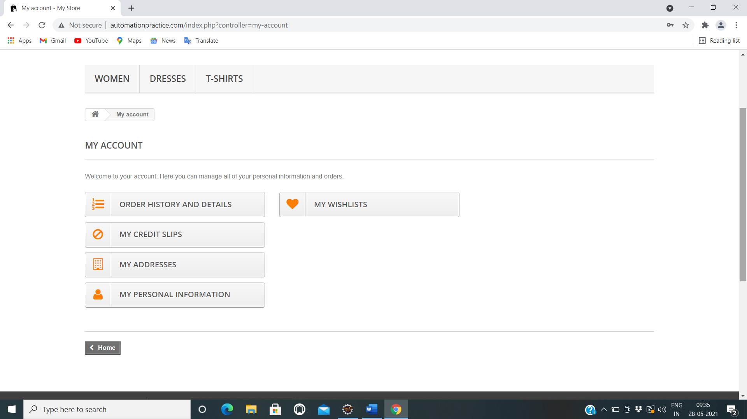

Thread.*sleep*(5000);

w.findElement(By.*xpath*("//span[contains(text(),'Order history and details')]")).click();

w.findElement(By.*xpath*("//body[1]/div[1]/div[2]/div[1]/div[3]/div[1]/ul[1]/li[1]/a[1]/span[1]")).click();

w.findElement(By.*xpath*("//span[contains(text(),'My credit slips')]")).click();

w.findElement(By.*xpath*("//body[1]/div[1]/div[2]/div[1]/div[3]/div[1]/ul[1]/li[1]/a[1]/span[1]")).click();

w.findElement(By.*xpath*("//span[contains(text(),'My addresses')]")).click();

w.findElement(By.*xpath*("//body[1]/div[1]/div[2]/div[1]/div[3]/div[1]/ul[1]/li[1]/a[1]/span[1]")).click();

w.findElement(By.*xpath*("//span[contains(text(),'My personal information')]")).click();

w.findElement(By.*xpath*("//body[1]/div[1]/div[2]/div[1]/div[3]/div[1]/ul[1]/li[1]/a[1]/span[1]")).click();

w.findElement(By.*xpath*("//span[contains(text(),'My wishlists')]")).click();

w.findElement(By.*id*("name")).sendKeys("Atchu");

w.findElement(By.*id*("submitWishlist")).click();

w.findElement(By.*xpath*("//body[1]/div[1]/div[2]/div[1]/div[3]/div[1]/ul[1]/li[1]/a[1]/span[1]")).click();

w.findElement(By.*xpath*("//body/div[@id='page']/div[2]/div[1]/div[3]/div[1]/ul[1]/li[1]/a[1]")).click();

w.findElement(By.*xpath*("//header/div[2]/div[1]/div[1]/nav[1]/div[2]/a[1]")).click();

w.findElement(By.*xpath*("//body[1]/div[1]/div[2]/div[1]/div[3]/div[1]/ul[1]/li[1]/a[1]/span[1]")).click();

w.close();

**TC08 To test the functionality of “T-shirt button”**

w.findElement(By.*xpath*("//header/div[3]/div[1]/div[1]/div[6]/ul[1]/li[3]/a[1]")).click();

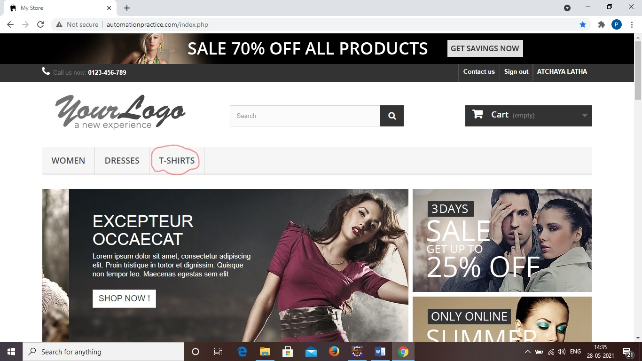

**TC09 To test the functionality of “All checkbox”**

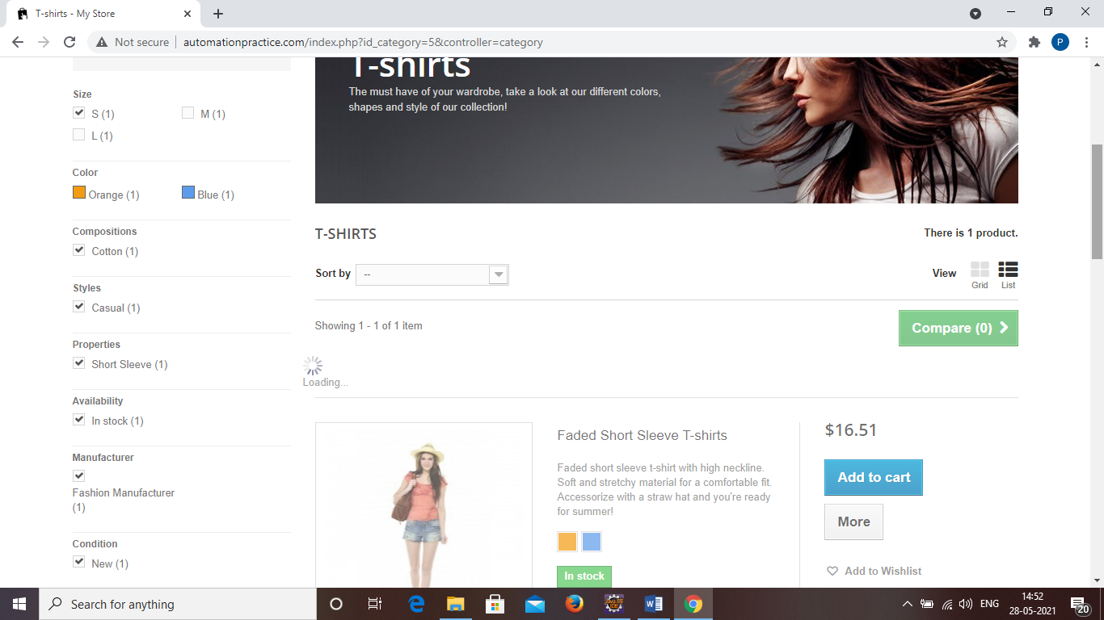

w.findElement(By.*id*("layered_id_attribute_group_1")).click();

w.findElement(By.*id*("layered_id_feature_5")).click();

w.findElement(By.*id*("layered_id_feature_11")).click();

w.findElement(By.*id*("layered_id_feature_17")).click();

w.findElement(By.*id*("layered_quantity_1")).click();

w.findElement(By.*id*("layered_manufacturer_1")).click();

w.findElement(By.*id*("layered_condition_new")).click();

**TC10 To test the functionality of “Sort by -dropdown”**

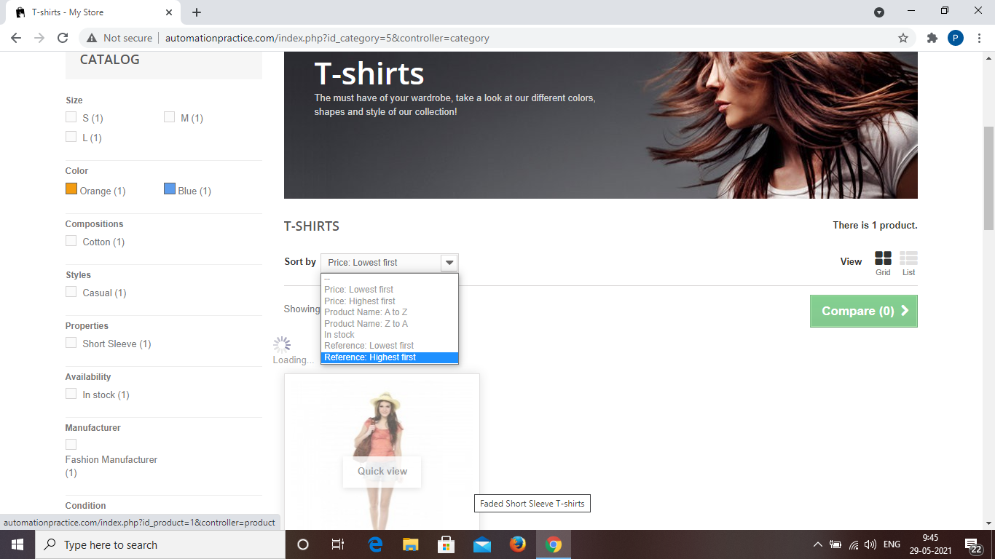

Select s=**new** Select (w.findElement(By.*id*("selectProductSort")));

s.selectByVisibleText("Price: Lowest first");

**TC11 To test the functionality of “List buttton”**

w.findElement(By.*xpath*("//body/div[@id='page']/div[2]/div[1]/div[3]/div[2]/div[2]/div[1]/ul[1]/li[3]/a[1]/i[1]")).click();

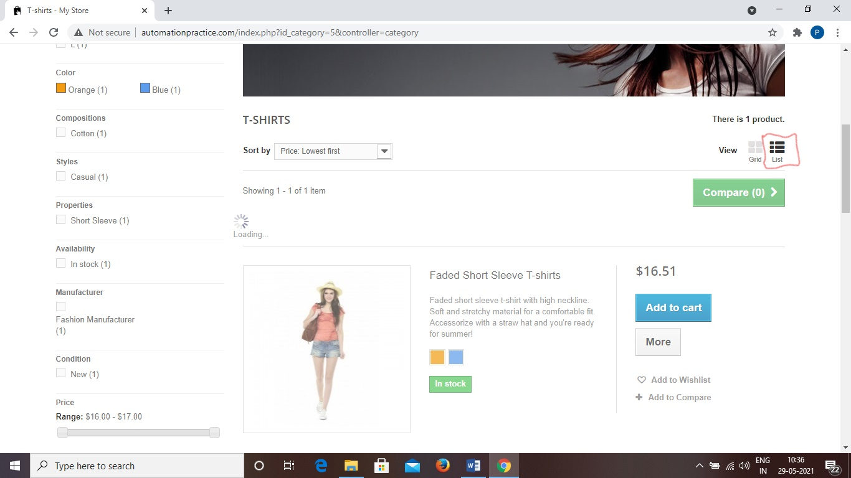

**TC12 To test the functionality of “Quick view button”**

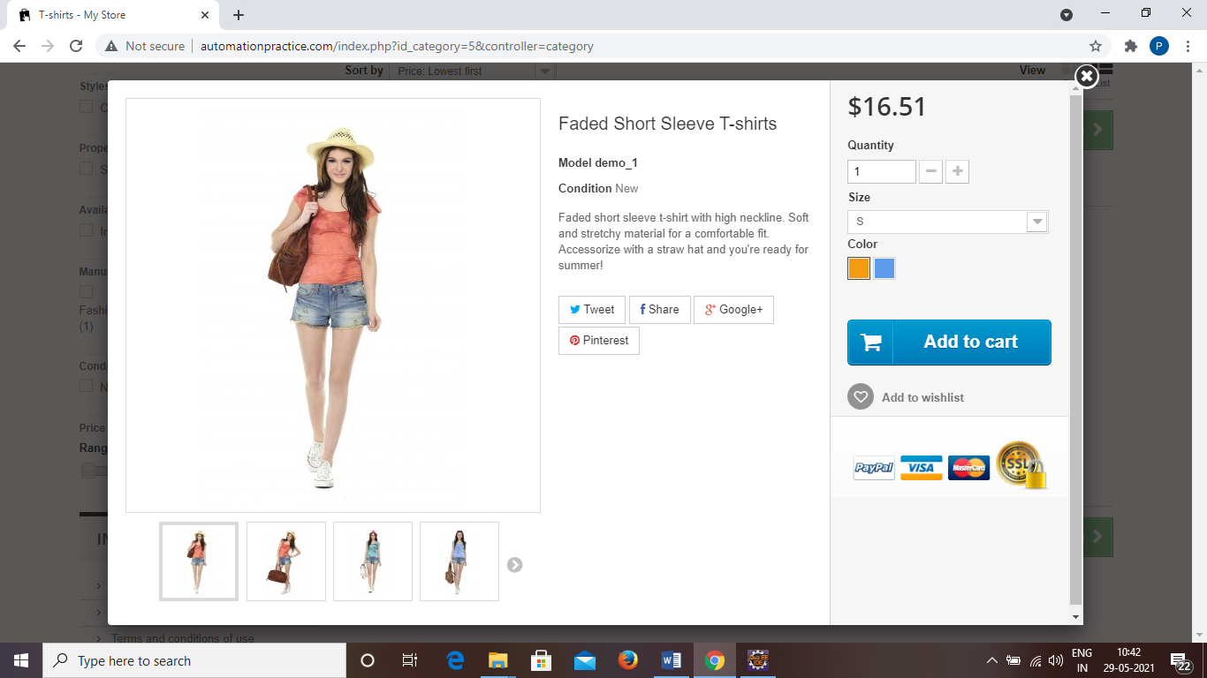

w.findElement(By.*xpath*("//span[contains(text(),'More')]")).click();

Thread.*sleep*(1000);

**TC13 To test the functionality of “View larger button”**

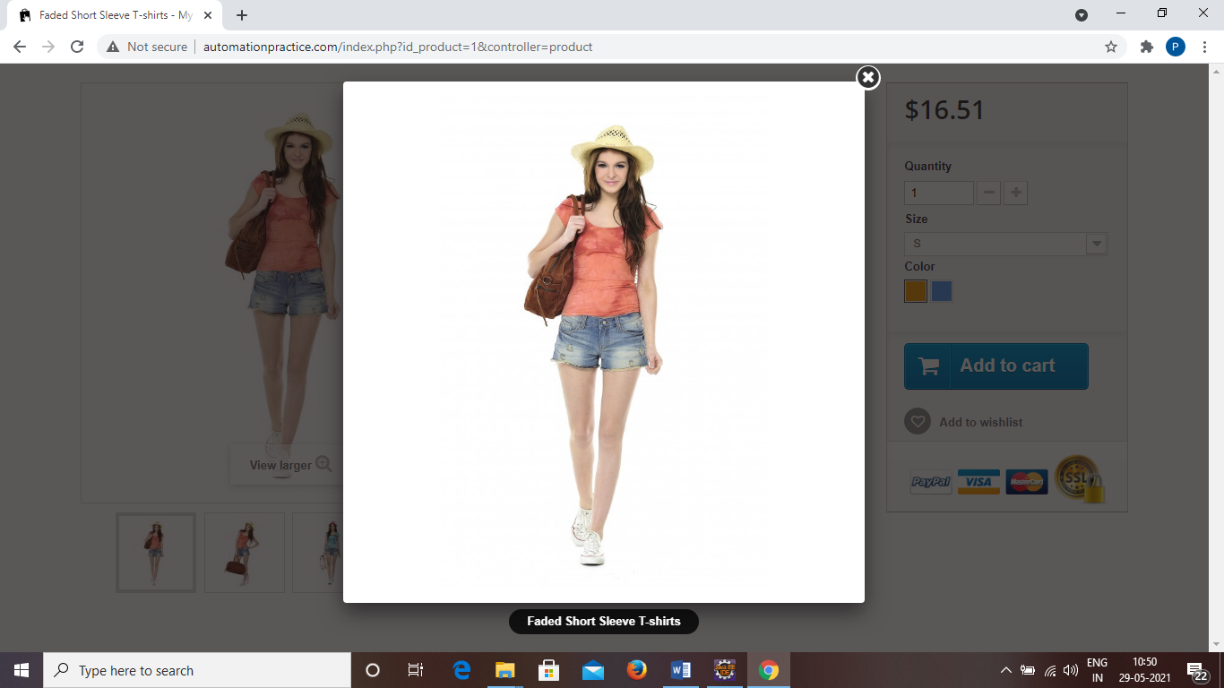

w.findElement(By.*id*("thumb_1")).click();

Thread.*sleep*(2000);

w.findElement(By.*xpath*("/html[1]/body[1]/div[2]/div[1]/div[1]/a[1]")).click();

w.findElement(By.*id*("thumb_2")).click();

Thread.*sleep*(2000);

w.findElement(By.*xpath*("/html[1]/body[1]/div[2]/div[1]/div[1]/a[1]")).click();

w.findElement(By.*id*("thumb_3")).click();

Thread.*sleep*(2000);

w.findElement(By.*xpath*("/html[1]/body[1]/div[2]/div[1]/div[1]/a[1]")).click();

w.findElement(By.*id*("thumb_4")).click();

Thread.*sleep*(2000);

w.findElement(By.*xpath*("/html[1]/body[1]/div[2]/div[1]/div[1]/a[1]")).click();

Thread.*sleep*(1000);

**TC14 To test the functionality of “Add to cart button”**

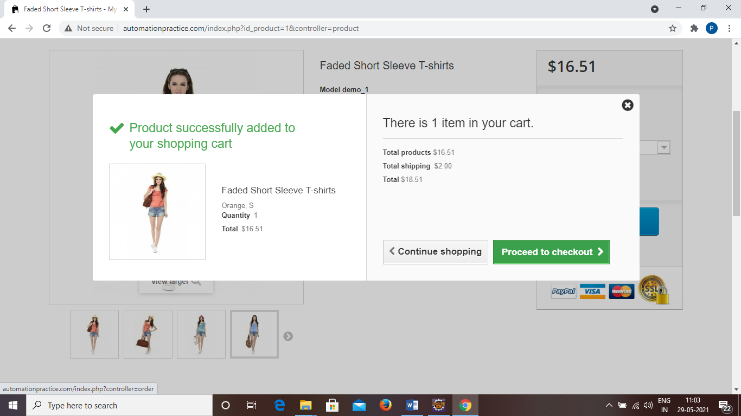

w.findElement(By.*xpath*("//span[contains(text(),'Add to cart')]"))

.click();

Thread.*sleep*(3000);

w.navigate().back();

**TC15 To test the functionality of “Cart”**

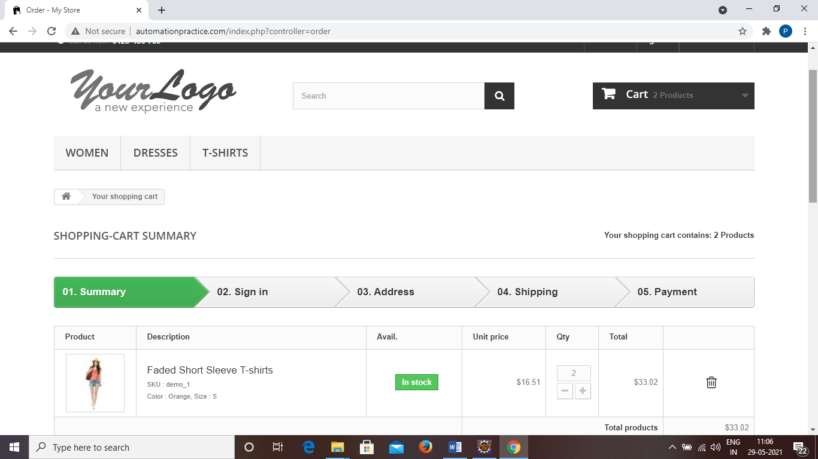

w.findElement(By.*xpath*("//header/div[3]/div[1]/div[1]/div[3]/div[1]/a[1]")).click()

Thread.*sleep*(1000);

**TC16 To test the functionality of “Proceed to checkout button”**

w.findElement(By.*xpath*("//body[1]/div[1]/div[2]/div[1]/div[3]/div[1]/p[2]/a[1]/span[1]")).click();

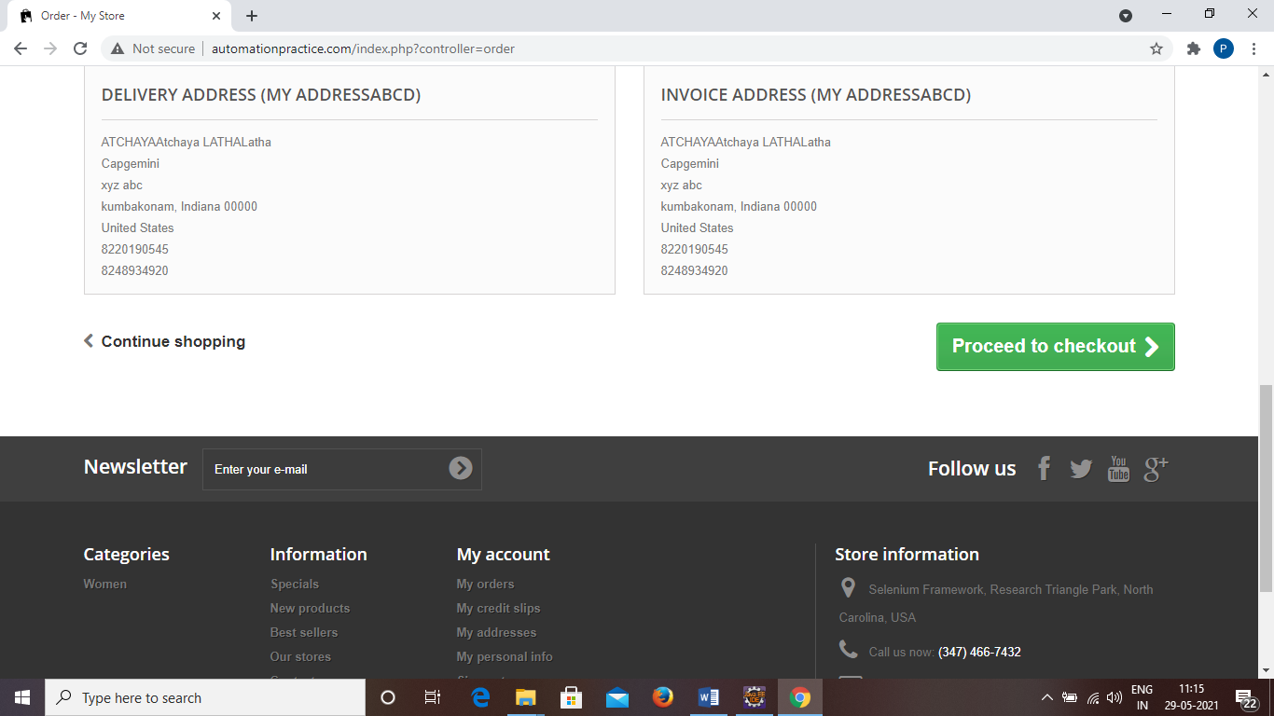

**TC17 To test the functionality of “Already Registered”**

w.findElement(By.*id*("email")).sendKeys("atchaya17@gmail.com");

w.findElement(By.*id*("passwd")).sendKeys("Atchu@0328");

w.findElement(By.*id*("SubmitLogin")).click();

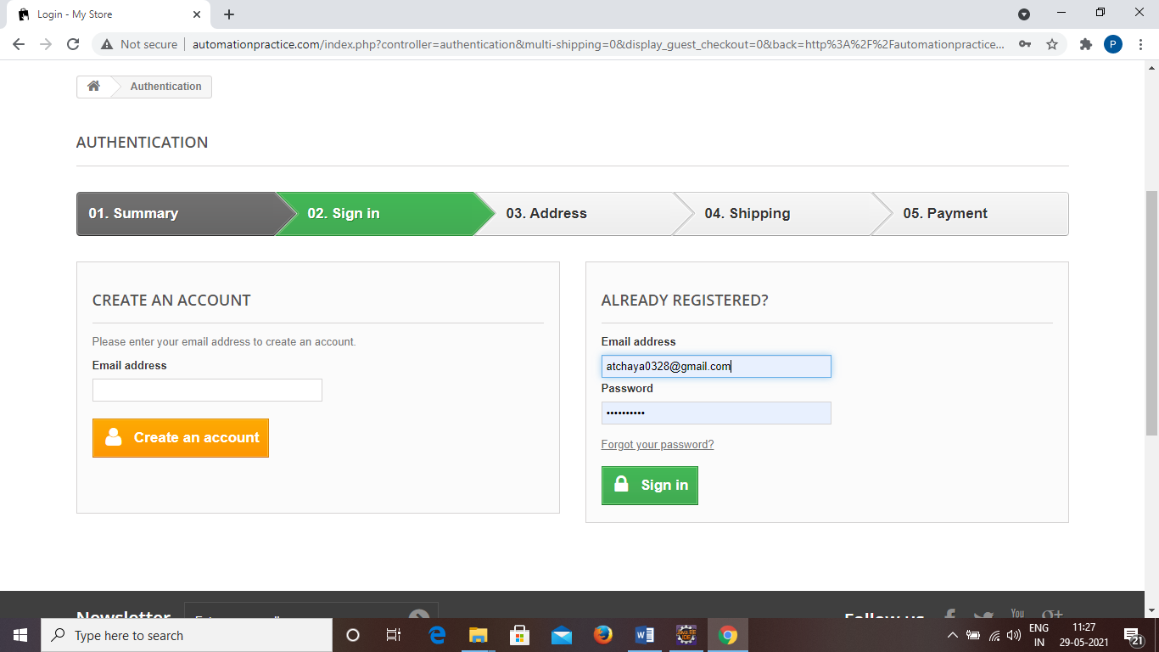

**TC18 To test the functionality of “Address”**

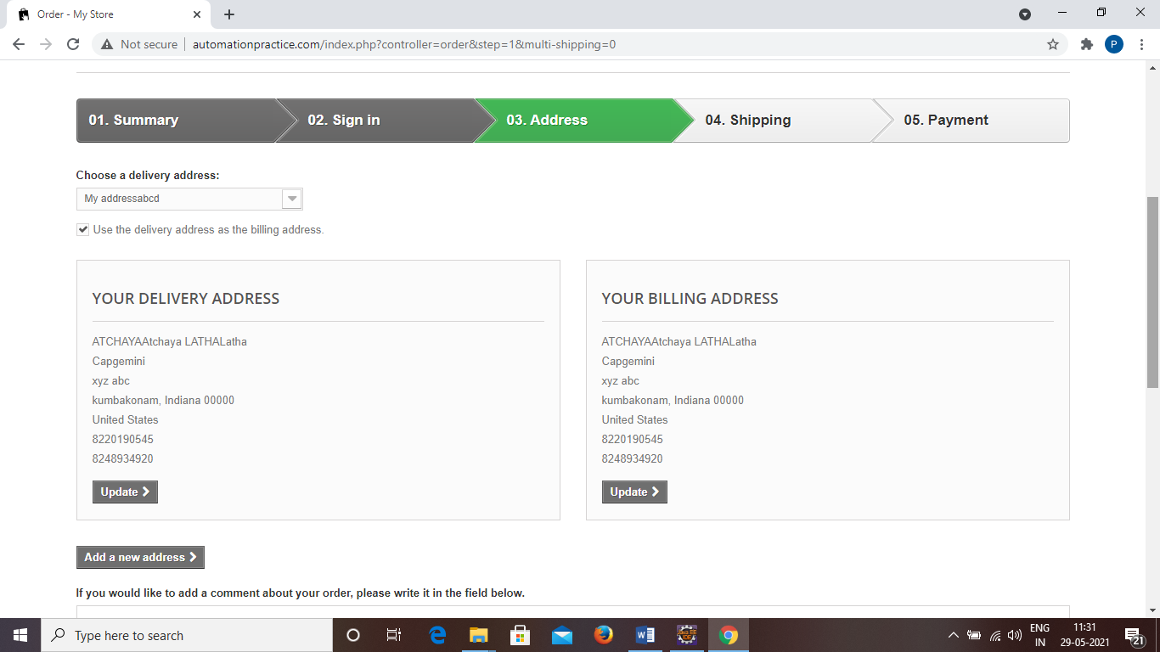

w.findElement(By.*name*("processAddress")).click();

**TC19 To test the functionality of “Shipping”**

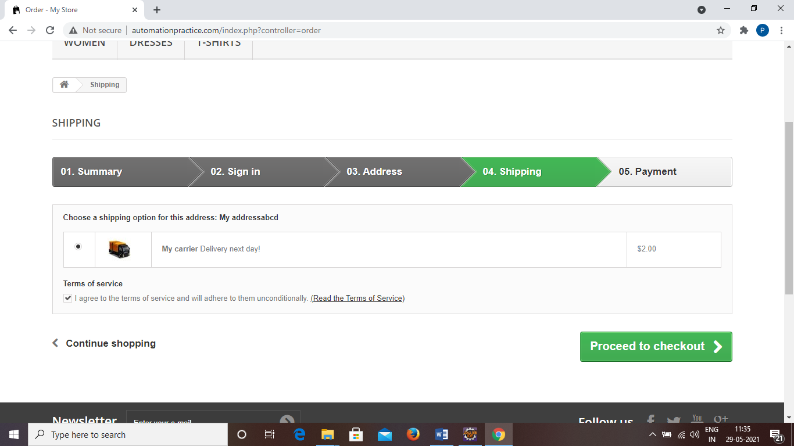

w.findElement(By.*id*("cgv")).click();

w.findElement(By.*name*("processCarrier")).click();

**TC20 To test the functionality of “Payment”**

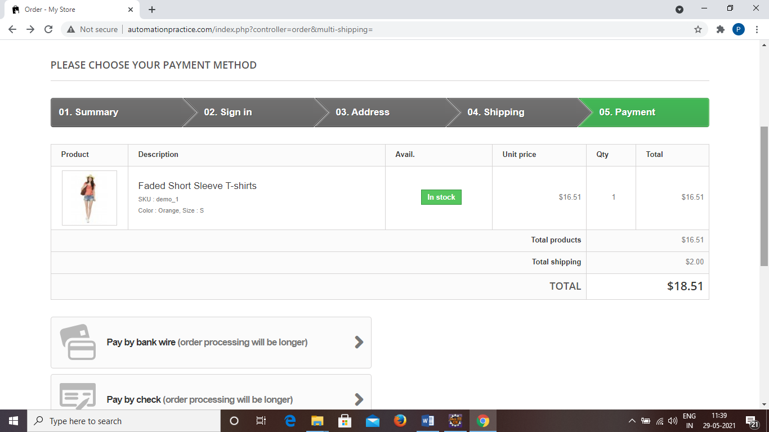

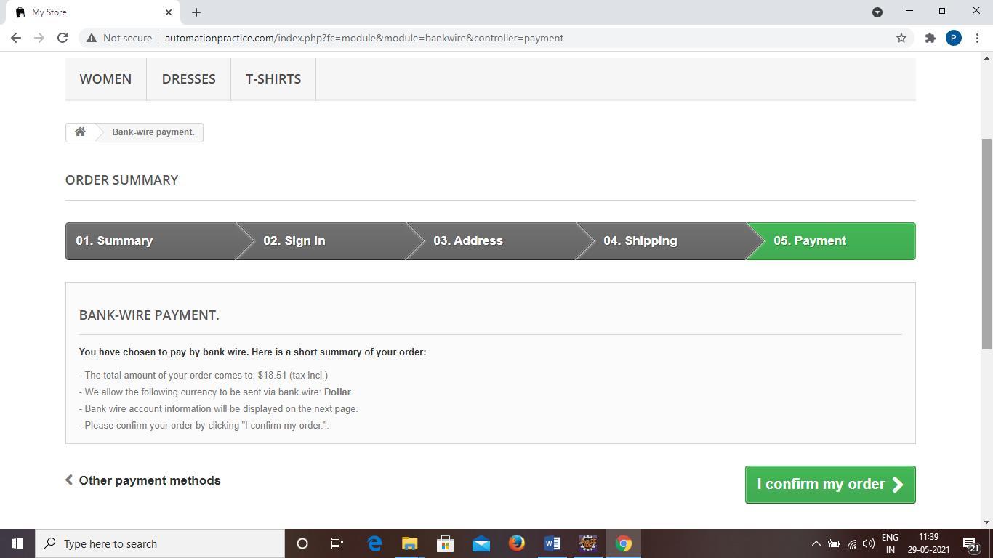

w.findElement(By.*xpath*("//body[1]/div[1]/div[2]/div[1]/div[3]/div[1]/div[1]/div[3]/div[1]/div[1]/p[1]/a[1]/span[1]")).click();

w.findElement(By.*xpath*("//body[1]/div[1]/div[2]/div[1]/div[3]/div[1]/form[1]/p[1]/button[1]/span[1]")).click();

**TC21 To Take the screenshot of “Order Confirmation”**

TakesScreenshot t = (TakesScreenshot) w;

File src = t.getScreenshotAs(OutputType.***FILE***);

Files.*copy*(src, **new** File("F:\\Screenshot\\P345.png"));

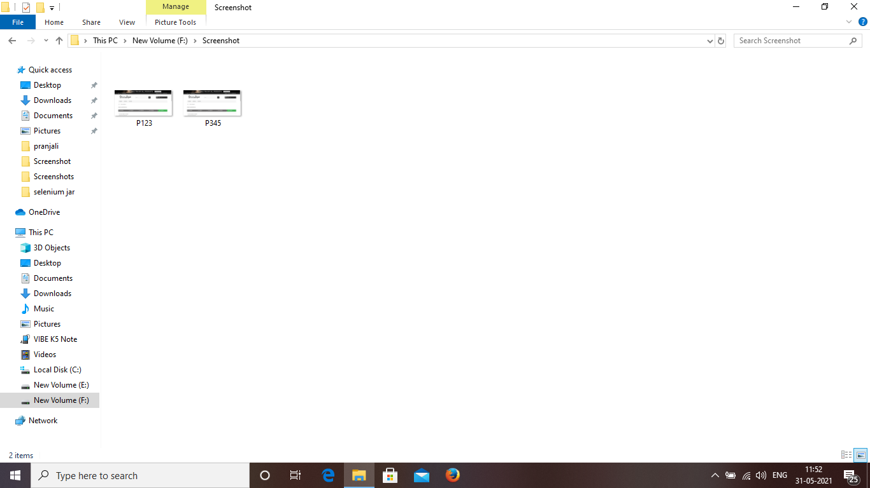

**TC22 To test the functionality of “Back to orders”**

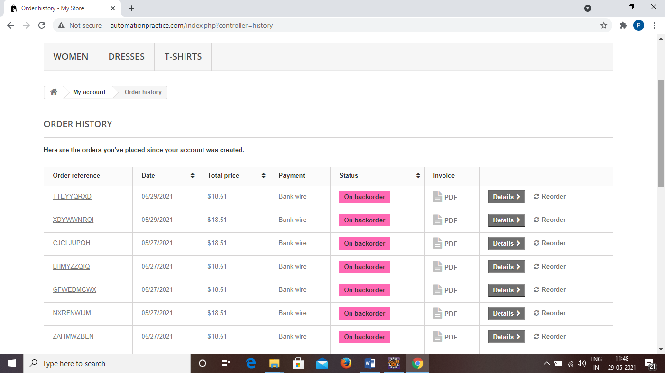

w.findElement(By.*xpath*("//body/div[@id='page']/div[2]/div[1]/div[3]/div[1]/p[1]/a[1]")).click();

**TC23 To test the functionality of “Back to Home”**

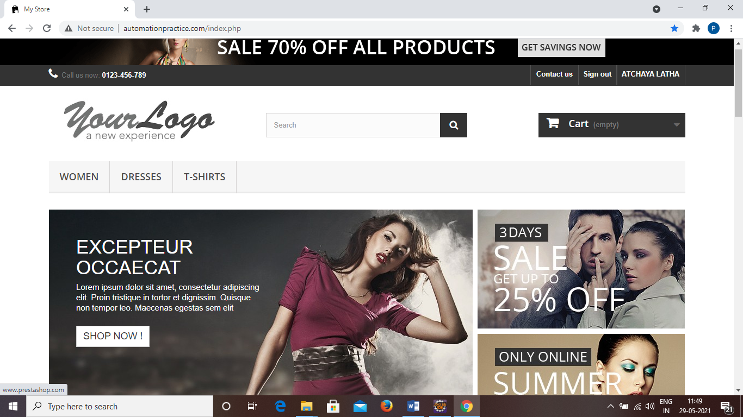

w.findElement(By.*xpath*("/html[1]/body[1]/div[1]/div[2]/div[1]/div[3]/div[1]/ul[1]/li[2]/a[1]/span[1]")).click()

w.close();

**To test the functionality of “Woman Tab”**

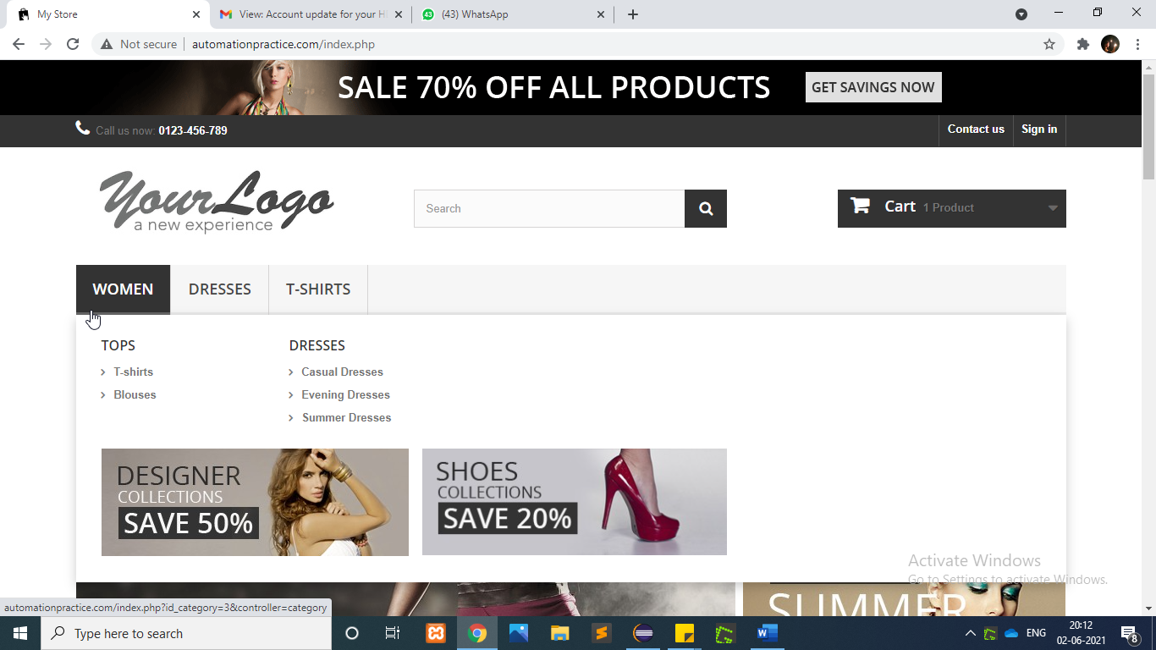

Actions actions=**new** Actions(w);

w.manage().timeouts().implicitlyWait(2000, TimeUnit.***MILLISECONDS***);

WebElement womenTab=w.findElement(By.*linkText*("WOMEN"));

WebElementTshirtTab=w.findElement(By.*xpath*("//div[@id='block_top_menu']/ul/li[1]/ul/li[1]/ul//a[@title='T-shirts']"));

actions.moveToElement(womenTab).moveToElement(TshirtTab).click().perform();

**To test the functionality of “Size Option”**

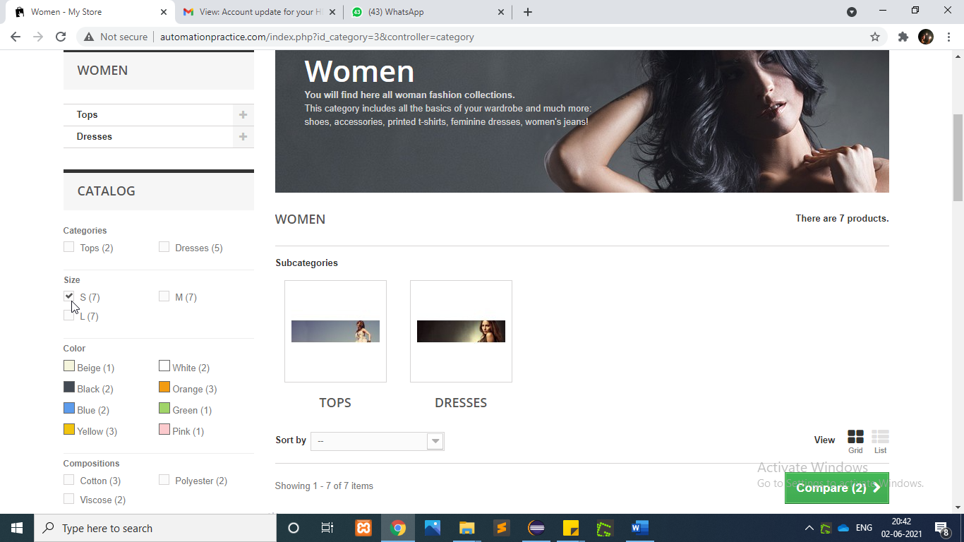

WebElement size=w.findElement(By.*xpath*("/html[1]/body[1]/div[1]/div[2]/

div[1]/div[3]/div[1]/div[1]/div[1]/form[1]/div[1]/div[1]/ul[1]/li[1]/div[1]/span[1]/input[1]"));

size.click();

**To test the functionality of “Composition** **Option”**

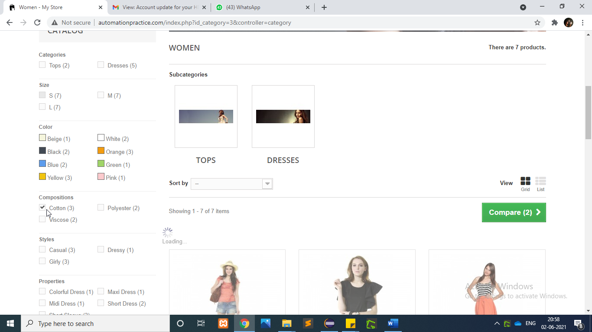

WebElement Compositions=w.findElement(By.*xpath*("/html[1]/body[1]/div[1]

/div[2]/div[1]/div[3]/div[1]/div[1]/div[1]/form[1]/div[1]/div[3]/ul[1]/li[1]/div[1]/span[1]/input[1]"));

Compositions.click();

**To test the functionality of “Style** **Option”**

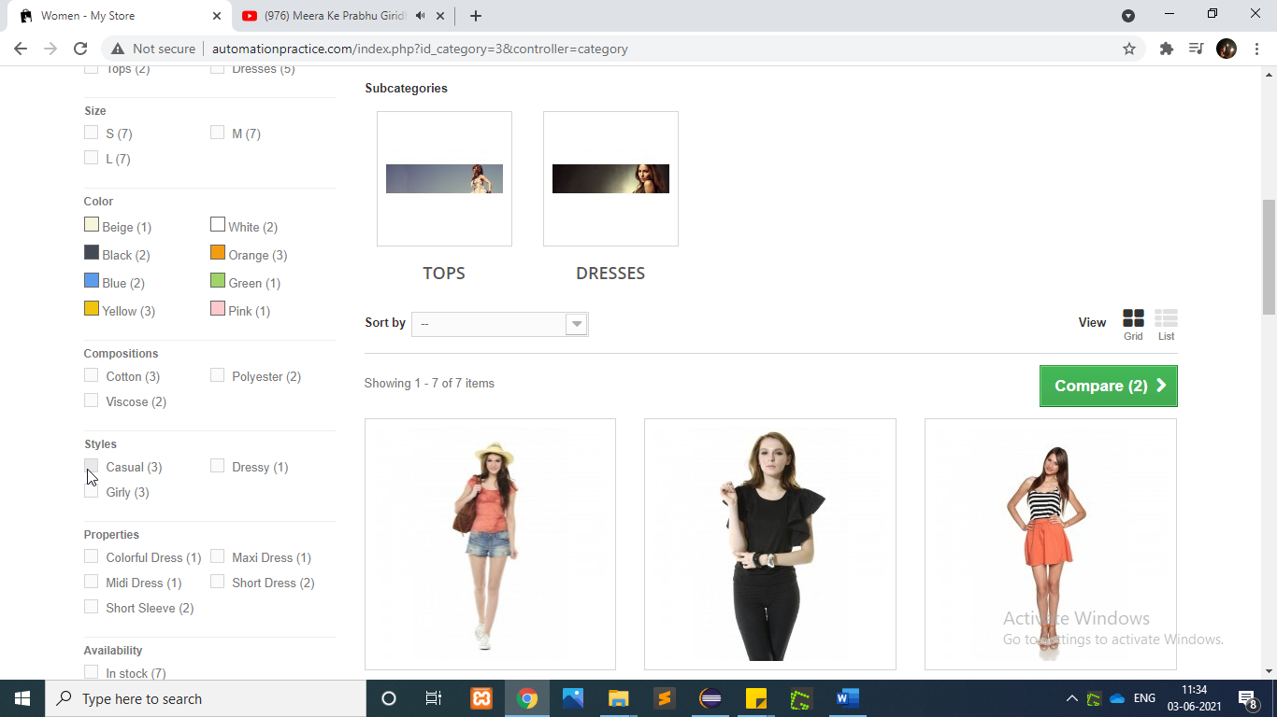

WebElement style=w.findElement(By.*xpath*("/html[1]/body[1]/div[1]/

div[2]/div[1]/div[3]/div[1]/div[1]/div[1]/form[1]/div[1]/div[3]/ul[1]/li[1]/div[1]/span[1]/input[1]"));

style.click();

**To test the functionality of “Search Box”**

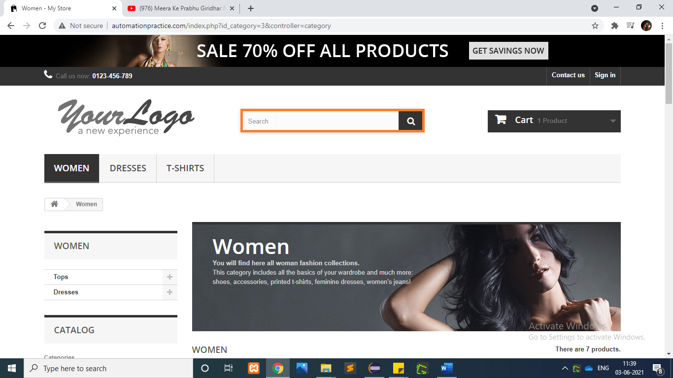

String ProductName=w.findElement(By.*xpath*("/html[1]/body[1]/div[1]/div[2]

/div[1]/div[3]/div[2]/ul[1]/li[1]/div[1]/div[2]/h5[1]/a[1]")).getText();

System.***out***.println(ProductName);

w.findElement(By.*id*("search_query_top")).sendKeys(ProductName);

w.findElement(By.*name*("submit_search")).click();

**To test the functionality of “Sort Using Selecting Category”**

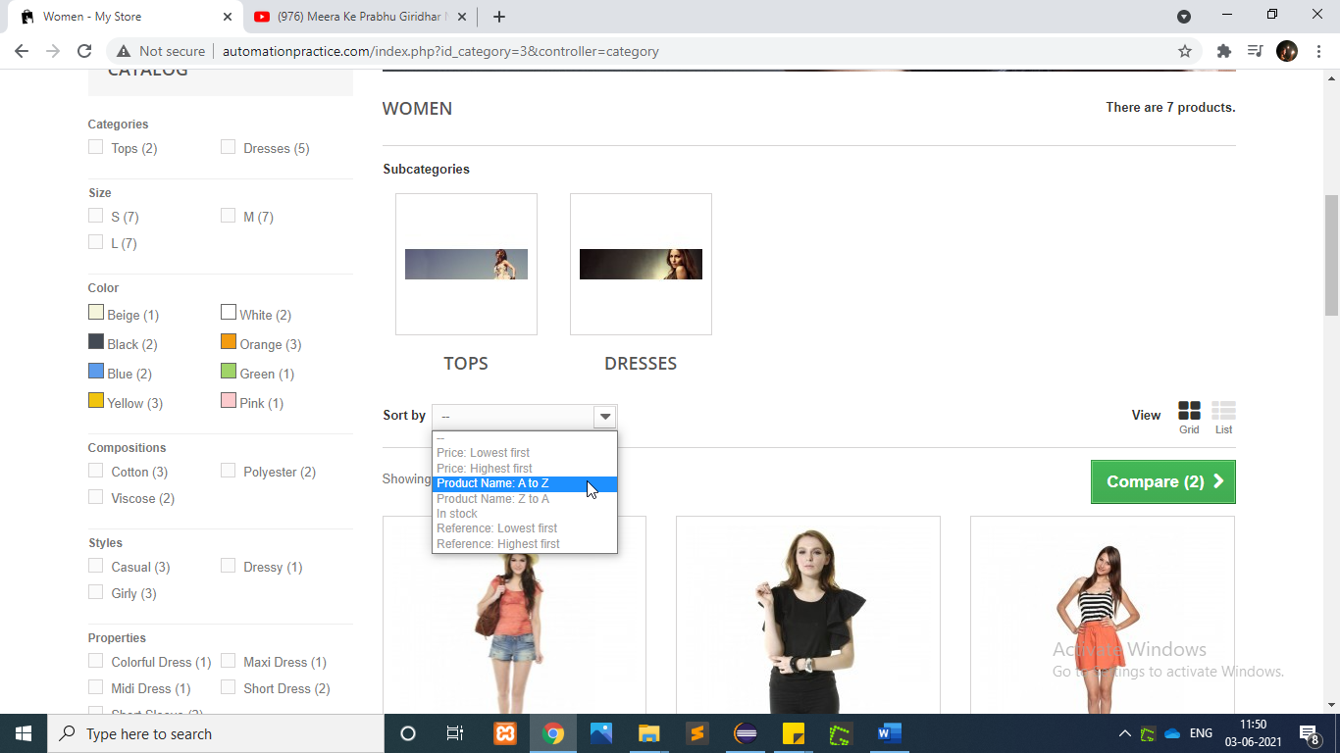

WebElement productCategory=w.findElement(By.*id*("selectProductSort"));

Select pSelectC=**new** Select(productCategory);

pSelectC.selectByVisibleText("Product Name: A to Z");

w.navigate().back();

**To test the functionality of “Sign In”**

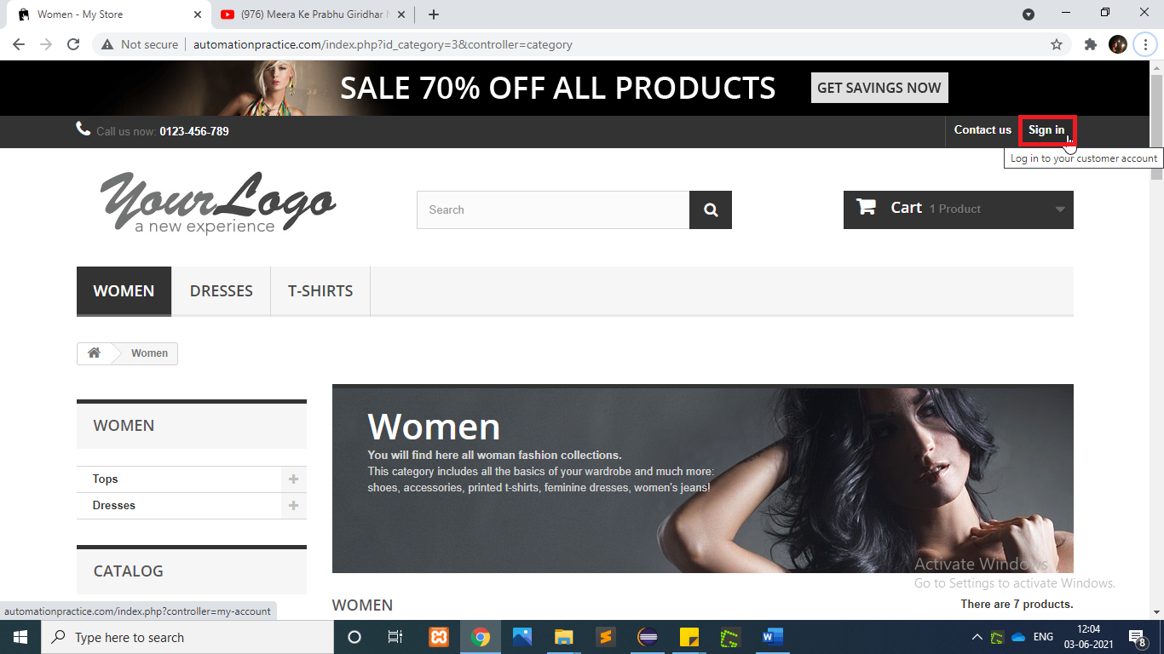

w.findElement(By.*linkText*("Sign in")).click();

**To test the functionality of “Login Button”**

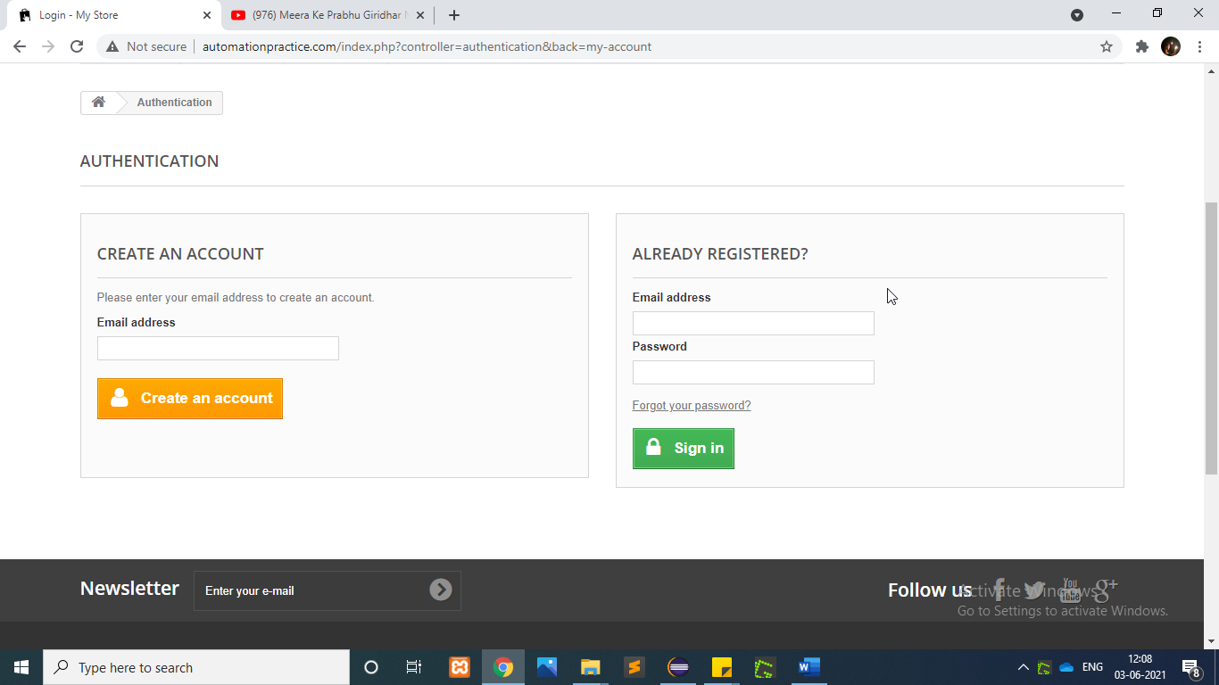

w.findElement(By.*id*("email")).sendKeys("vsoft1120@test.com");

w.findElement(By.*id*("passwd")).sendKeys("vosft1212");

w.findElement(By.*id*("SubmitLogin")).click();

**To test the functionality of “More Button”**

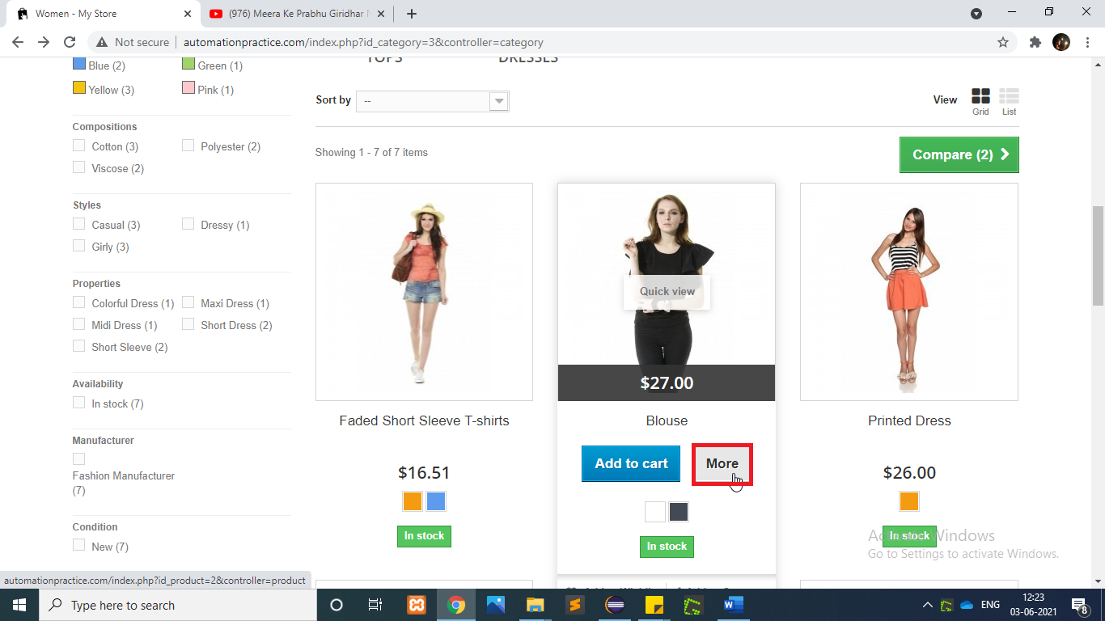

w.findElement(By.*xpath*("/html[1]/body[1]/div[1]/div[1]/header[1]/div[3]/div[1]/div[1]/div[6]/ul[1]/li[1]/a[1]")).click();

WebElement SecondImg=w.findElement(By.*xpath*("/html/body/div[1]/div[2]

/div/div[3]/div[2]/ul/li[2]/div/div[1]/div/a[1]/img"));

WebElement MoreButton=w.findElement(By.*xpath*("/html/body[1]/div[1]/div[2]

/div[1]/div[3]/div[2]/ul/li[2]/div[1]/div[2]/div[2]/a[2]"));

Actions actions1=**new** Actions(w); actions1.moveToElement(SecondImg).moveToElement(MoreButton).click().perform();

**To test the functionality of “Increase The Quantity”**

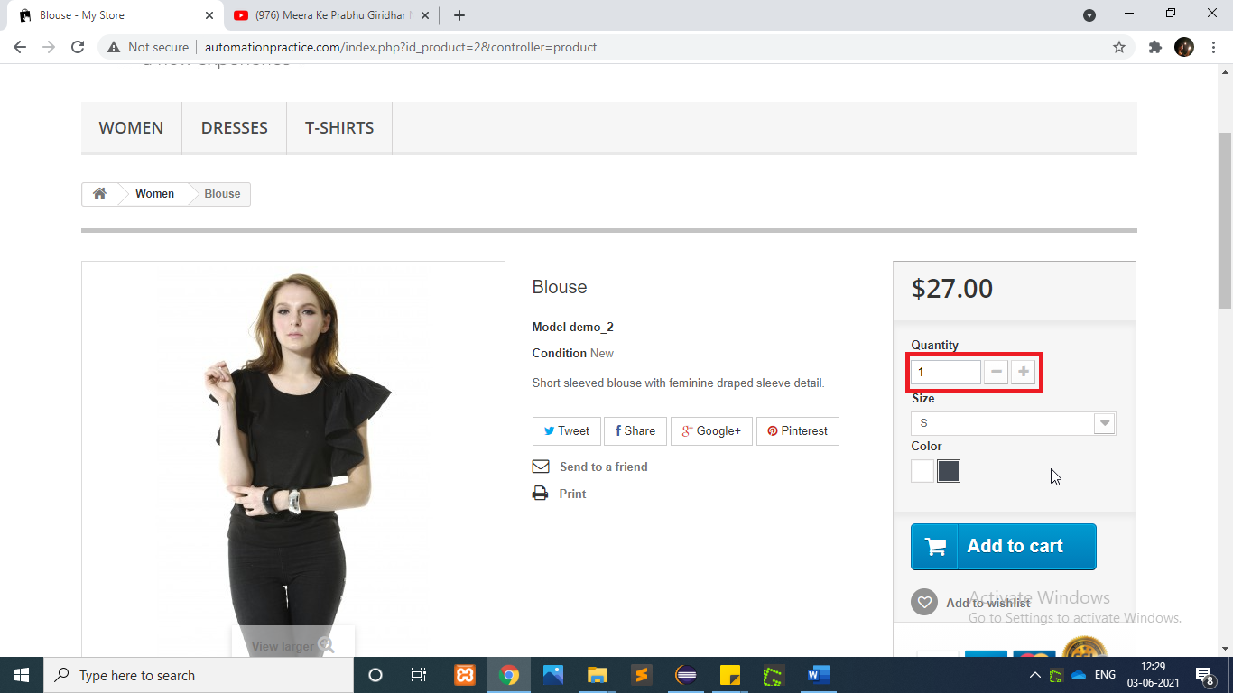

w.findElement(By.*id*("quantity_wanted")).clear();

w.findElement(By.*id*("quantity_wanted")).sendKeys("2");

**To test the functionality of “Select The Size”**

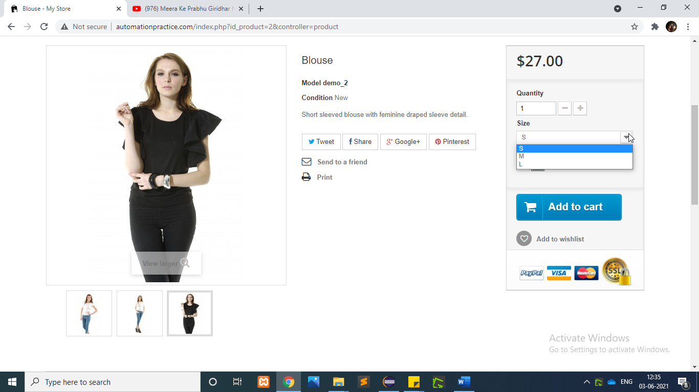

WebElement Sizedrpdwn=w.findElement(By.*xpath*("//*[@id='group_1']"));

Select orderSelect=**new** Select(Sizedrpdwn);

orderSelect.selectByVisibleText("M");

**To test the functionality of “Select The Color”**

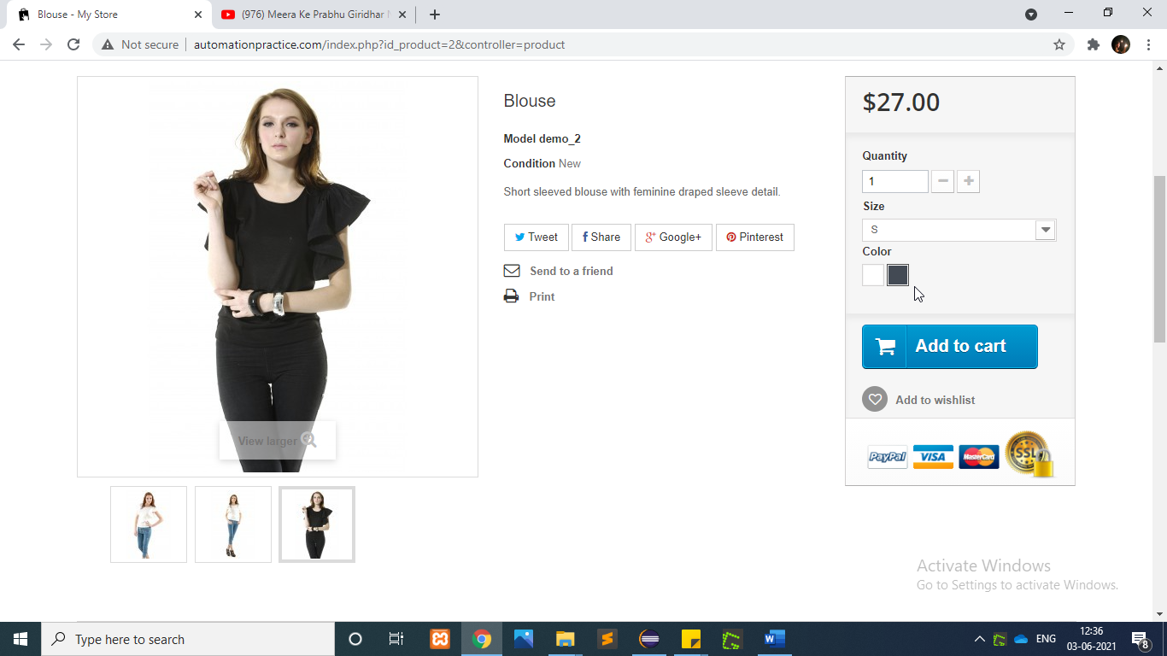

w.findElement(By.*id*("color_11")).click();

**To test the functionality of “Add To Cart(Woman)”**

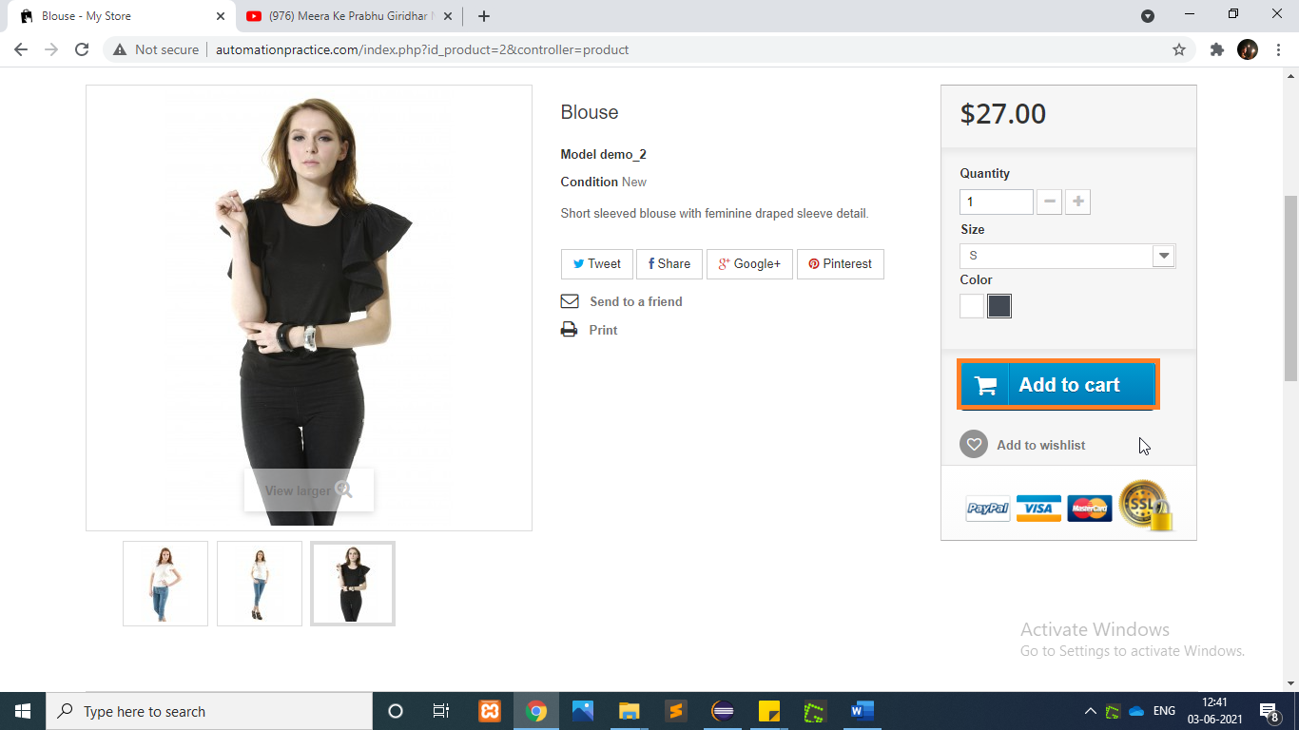

w.findElement(By.*xpath*("//p[@id='add_to_cart']//span[.='Add to cart']")).click();

**To test the functionality of “Proceed to Checkout”**

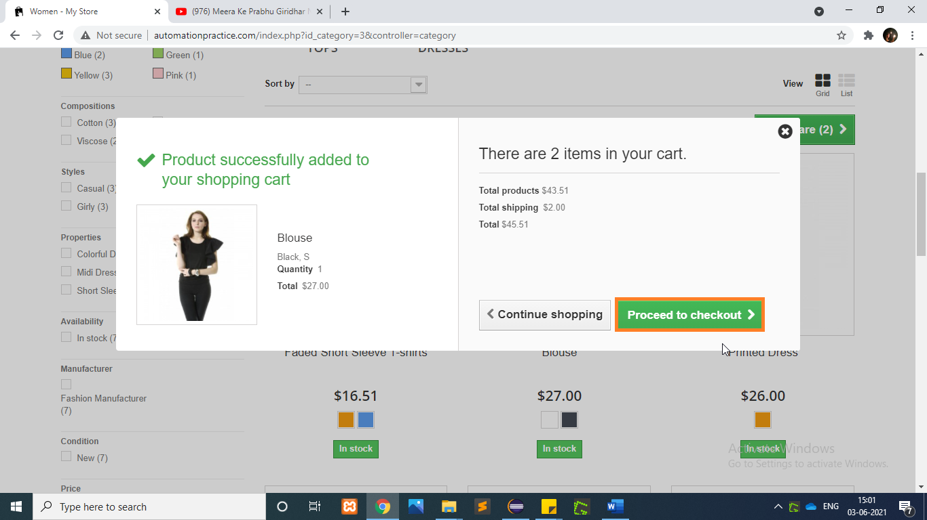

w.findElement(By.*xpath*("/html[1]/body[1]/div[1]/div[1]/header[1]/div[3]/div[1]/div[1]/div[4]/div[1]/div[2]/div[4]/a[1]/span[1]")).click();

**To test the functionality of “Summery”**

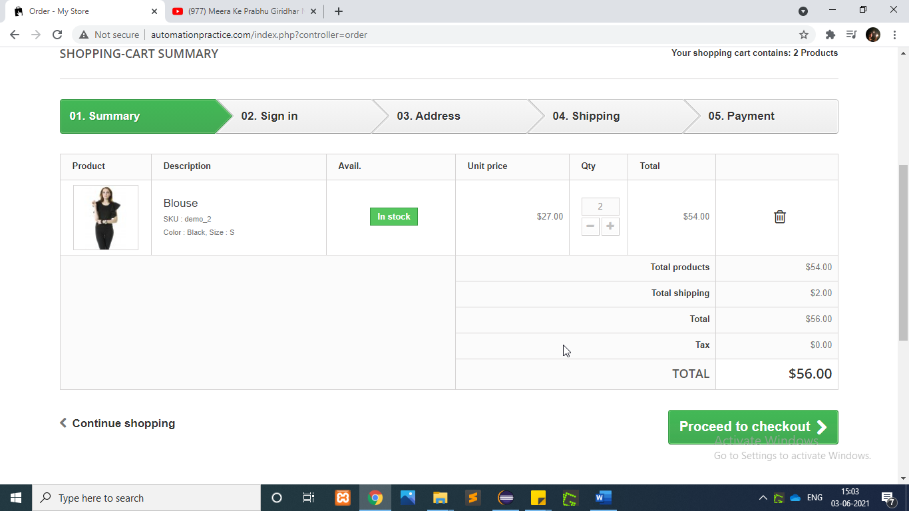

**To test the functionality of “Checkout to proceed”**

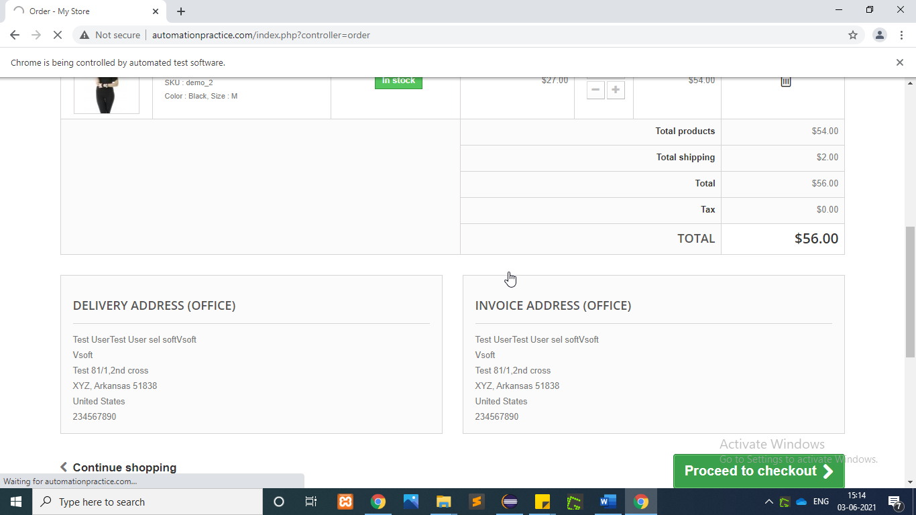

w.findElement(By.*xpath*("/html/body/div[1]/div[2]/div/div[3]/div/p[2]/a[1]/span")).click(); w.findElement(By.*xpath*("/html/body/div[1]/div[2]/div/div[3]/div/form/p/button/span")).click();

**To test the functionality of “Confirmed Address”**

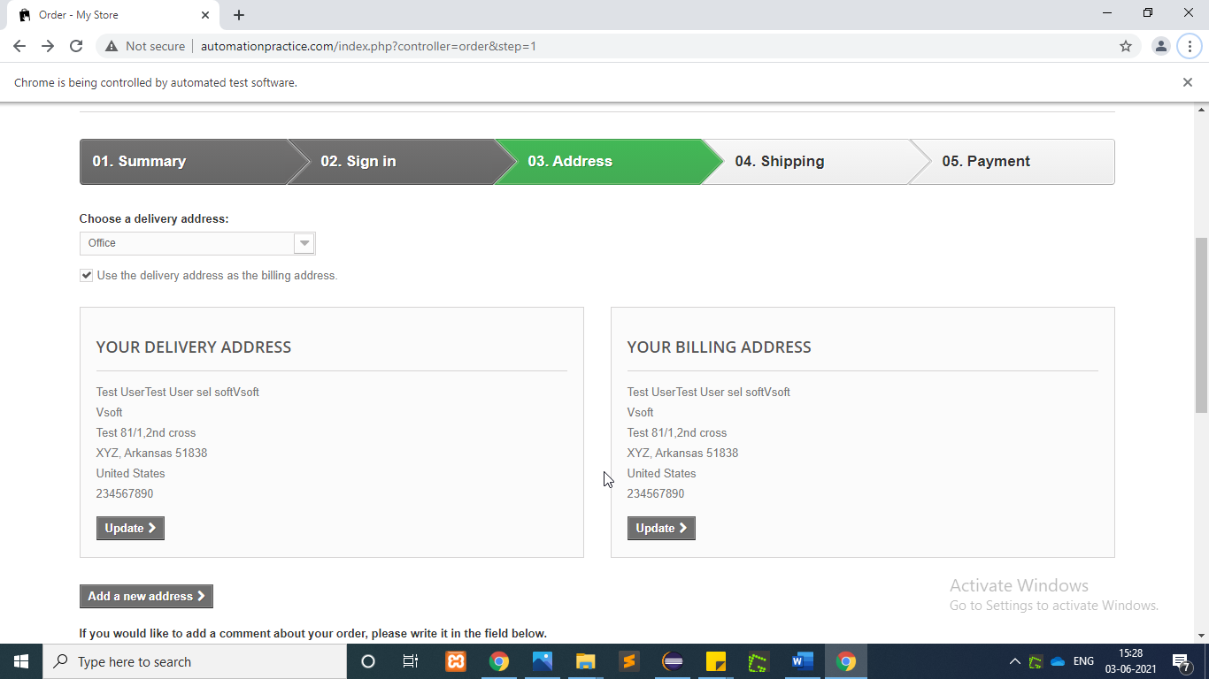

w.findElement(By.*xpath*("//*[@id=\"cgv\"]")).click(); w.findElement(By.*xpath*("/html/body/div[1]/div[2]/div/div[3]/div/div/form/p/button/span")).click();

**To test the functionality of “Shipping”**

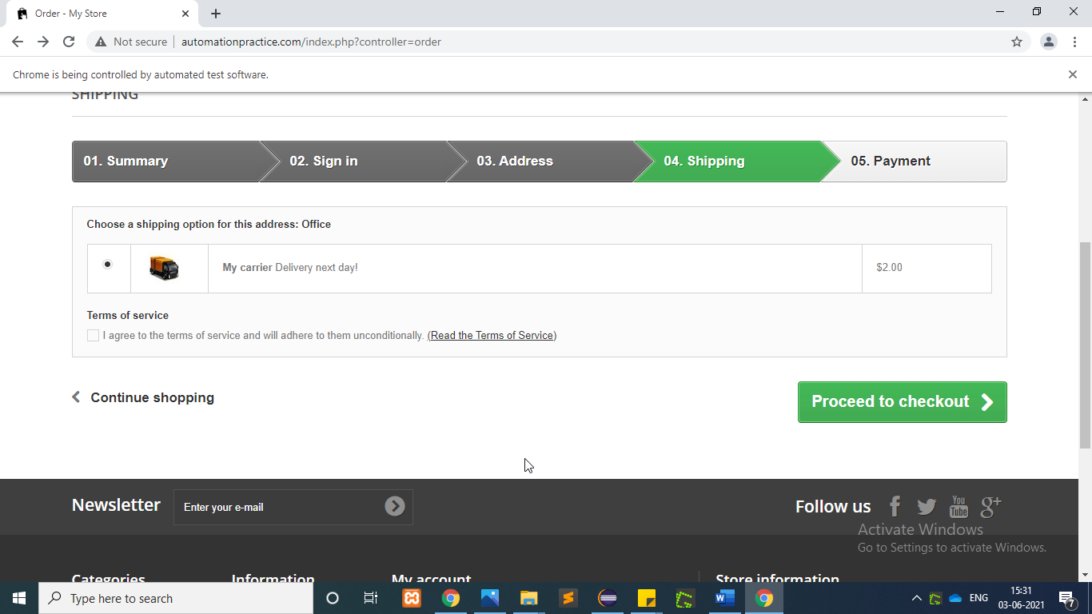

w.findElement(By.*xpath*("/html/body/div[1]/div[2]/div/div[3]/div/div/div[3]/div[2]/div/p/a")).click();

**To test the functionality of “Payment”**

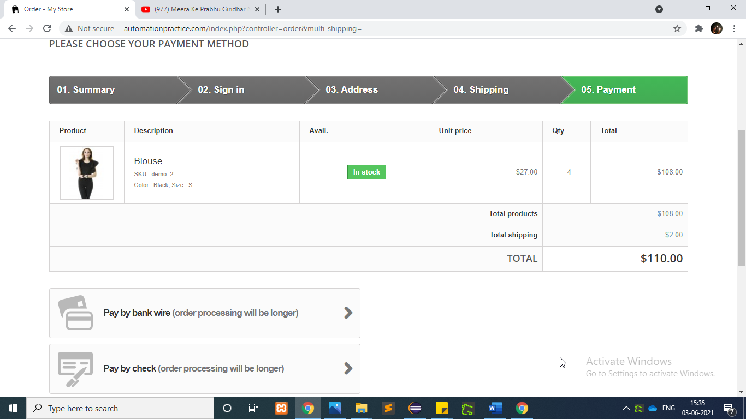

w.findElement(By.*xpath*("/html/body/div[1]/div[2]/div/div[3]/div/div/div[3]/div[2]/div/p/a")).click();

**To test the functionality of “Confirm order”**

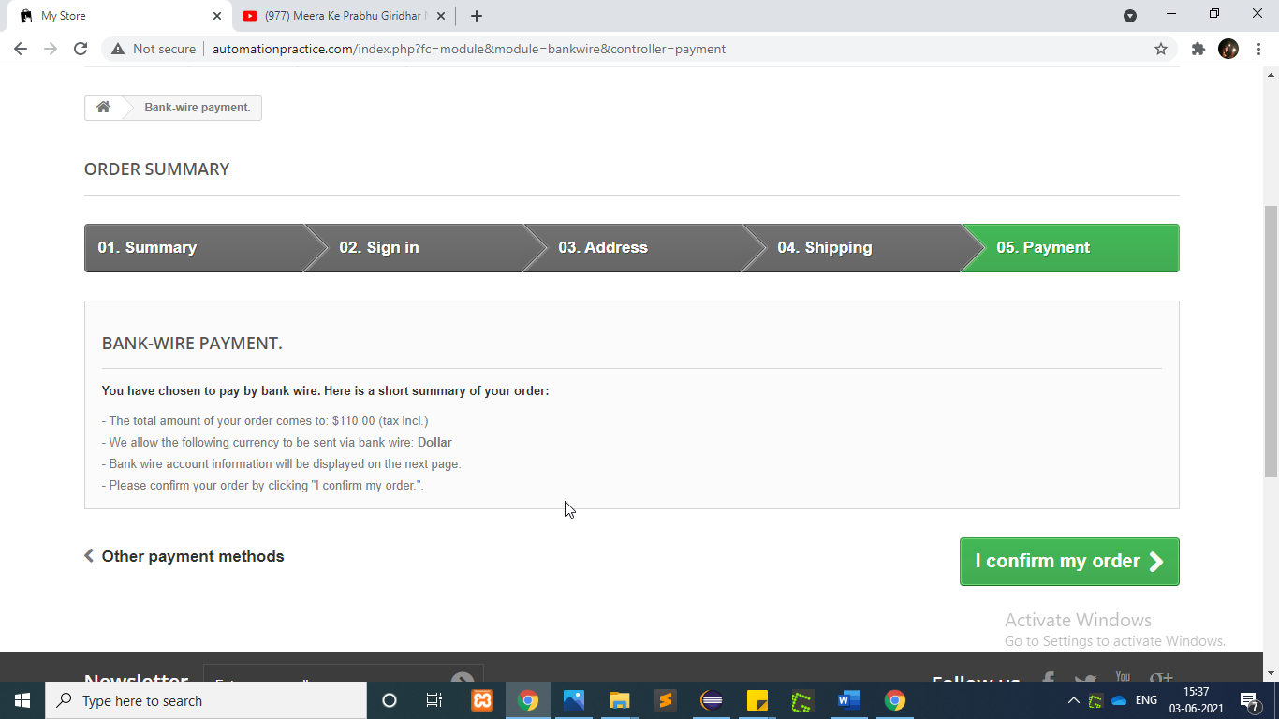

w.findElement(By.*xpath*("/html/body/div[1]/div[2]/div/div[3]/div/form/p/button/span")).click();

**To test the functionality of “Dresses Tab”**

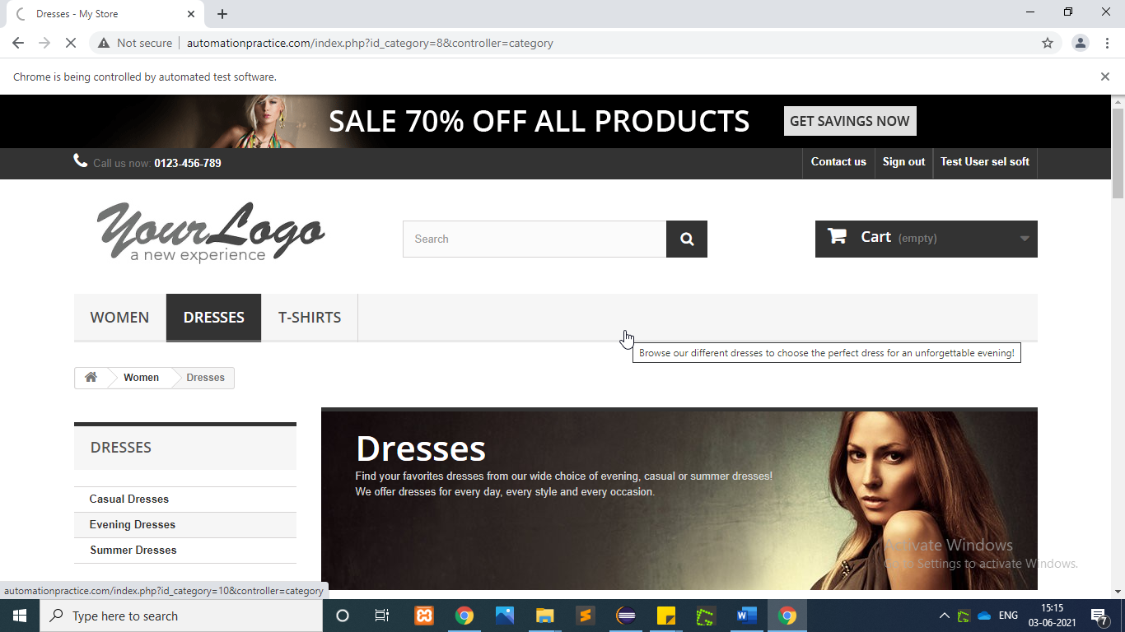

w.findElement(By.*xpath*("//header/div[3]/div[1]/div[1]/div[6]/ul[1]/li[2]/a[1]")).click();

**To test the functionality of “Confirm order”**

**To test the functionality of “Evening Dresses Tab”**

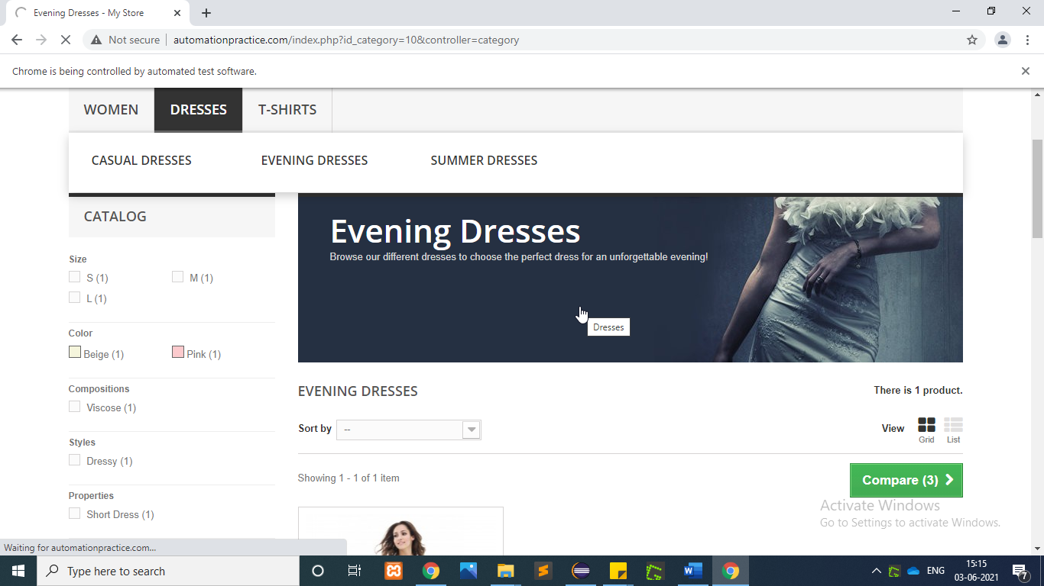

w.findElement(By.*linkText*("Evening Dresses")).click();

**To test the functionality of “Add To Wish”**

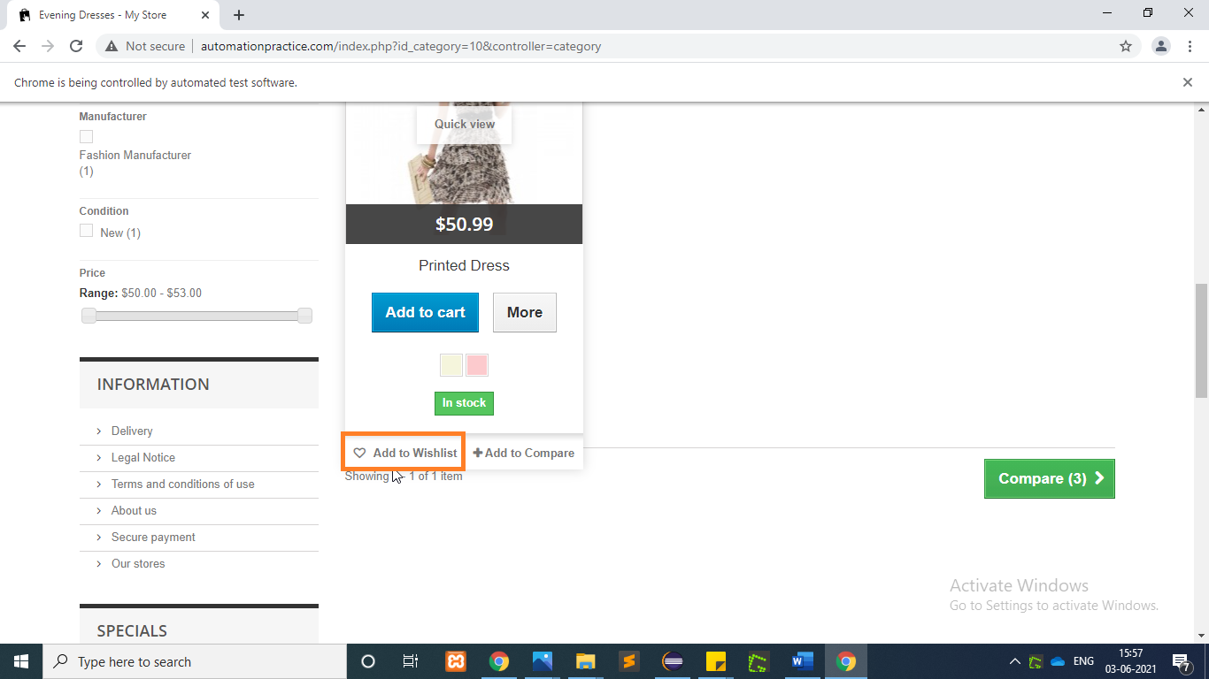

WebElement PrintedDress=w.findElement(By.*xpath*("/html[1]/body[1]/div[1]/

div[2]/div[1]/div[3]/div[2]/ul[1]/li[1]/div[1]/div[1]/div[1]/a[1]/img[1]"));

WebElement AddToWishlist=w.findElement(By.*xpath*("/html[1]/body[1]/div[1]

/div[2]/div[1]/div[3]/div[2]/ul[1]/li[1]/div[1]/div[3]/div[1]/a[1]"));

Actions actions2=**new** Actions(w);

actions2.moveToElement(PrintedDress).moveToElement(AddToWishlist).click().perform();

**To test the functionality of “Summer Dresses Tab”**

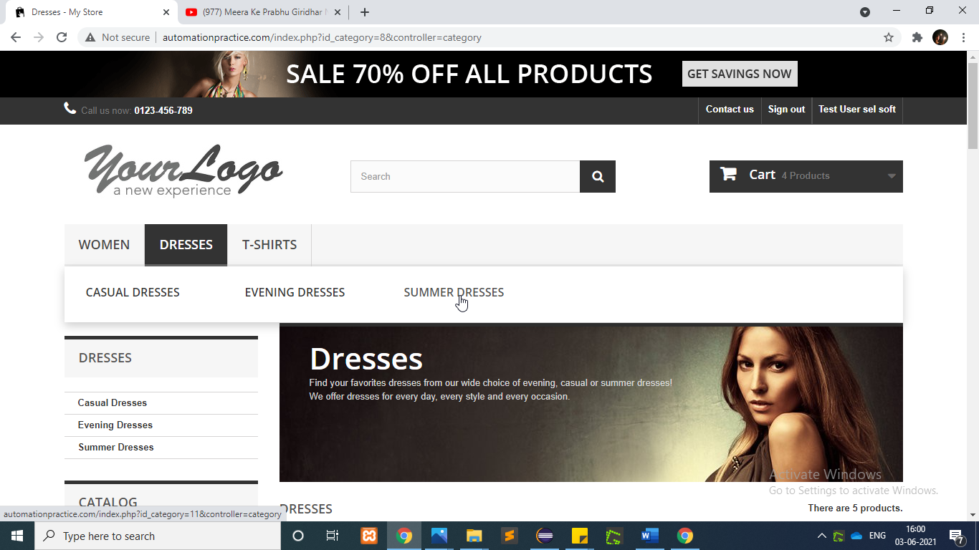

w.findElement(By.*xpath*("//header/div[3]/div[1]/div[1]/div[6]/ul[1]/li[2]/a[1]")).click();

w.findElement(By.*linkText*("Summer Dresses")).click();

**To test the functionality of “Add to Compare Dress1”**

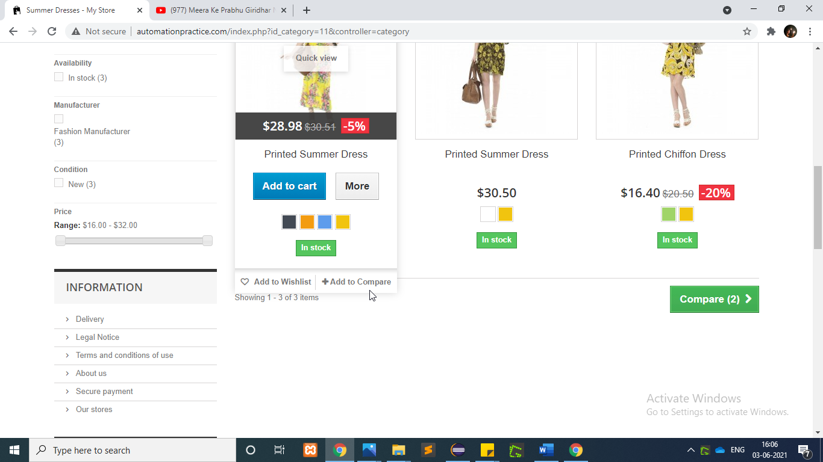

WebElement CompareDress1=w.findElement(By.*xpath*("/html[1]/

body[1]/div[1]/div[2]/div[1]/div[3]/div[2]/ul[1]/li[1]/div[1]/div[1]/div[1]/a[1]/img[1]"));

WebElement AddToCompare=w.findElement(By.*xpath*("/html[1]/body[1]

/div[1]/div[2]/div[1]/div[3]/div[2]/ul[1]/li[1]/div[1]/div[3]/div[2]/a[1]"));

Actions actions3=**new** Actions(w); actions3.moveToElement(CompareDress1).moveToElement(AddToCompare).click().perform();

**To test the functionality of “Add to Compare Dress2”**

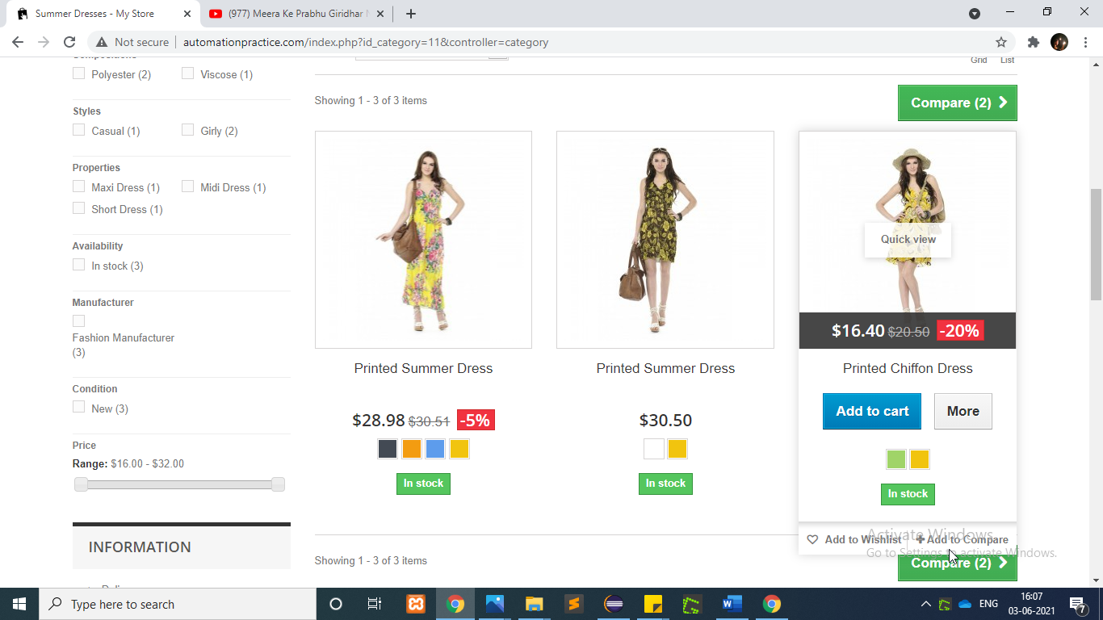

WebElement CompareDress2=w.findElement(By.*xpath*("/html[1]/body[1]/div[1]/div[2]/div[1]/div[3]/div[2]/ul[1]/li[3]/div[1]/div[2]"));

WebElement AddToCompare1=w.findElement(By.*xpath*("/html[1]/body[1]/div[1]/div[2]/div[1]/div[3]/div[2]/ul[1]/li[3]/div[1]/div[3]/div[2]/a[1]"));

Actions actions4=**new** Actions(w);

actions4.moveToElement(CompareDress2).moveToElement(AddToCompare1).click().perform();

**To test the functionality of “Compare Button”**

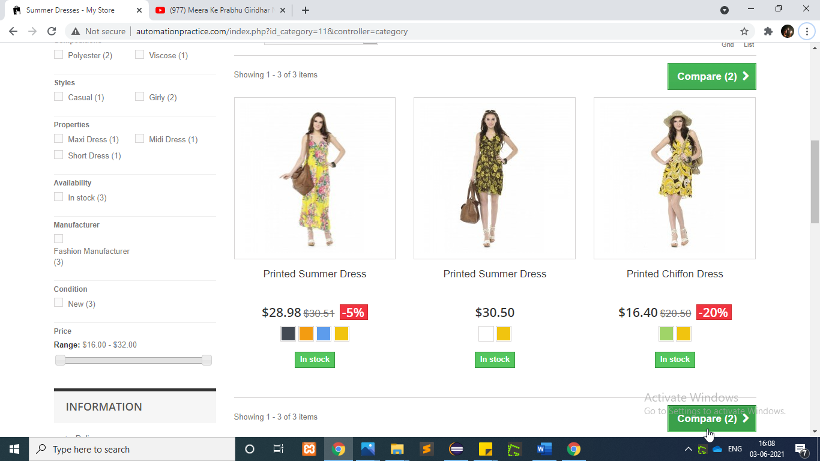

w.findElement(By.*xpath*("/html[1]/body[1]/div[1]/div[2]/div[1]/div[3]/div[2]/div[2]/div[2]/form[1]")).click();

w.findElement(By.*xpath*("/html[1]/body[1]/div[1]/div[2]/div[1]/div[3]/div[1]/ul[1]/li[1]/a[1]/span[1]")).click();

**To test the functionality of “MenuBar”**

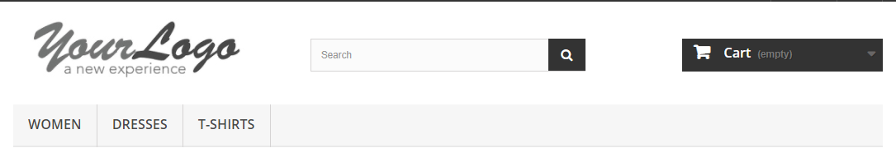

//click on woman

w.findElement(By.*linkText*("WOMEN")).click();

w.navigate().back();

//click on dresses

w.findElement(By.*xpath*("/html[1]/body[1]/div[1]/div[1]/header[1]/div[3]/div[1]/div[1]/div[6]/ul[1]/li[2]/a[1]")).click();

w.navigate().back();

//click on t-shirt

w.findElement(By.*xpath*("/html[1]/body[1]/div[1]/div[1]/header[1]/div[3]/div[1]/div[1]/div[6]/ul[1]/li[3]/a[1]")).click();

w.navigate().back();

**To test the functionality of “Search Bar”**



//serach bar

String ProductName=w.findElement(By.*xpath*("/html[1]/body[1]/div[1]/div[2]/div[1]/div[2]/div[1]/div[1]/ul[1]/li[3]/div[1]/div[2]/h5[1]/a[1]")).getText();

System.***out***.println(ProductName);

w.findElement(By.*id*("search_query_top")).sendKeys(ProductName);

w.findElement(By.*name*("submit_search")).click();

w.navigate().back();

**To test the functionality of “Best Sellers”**

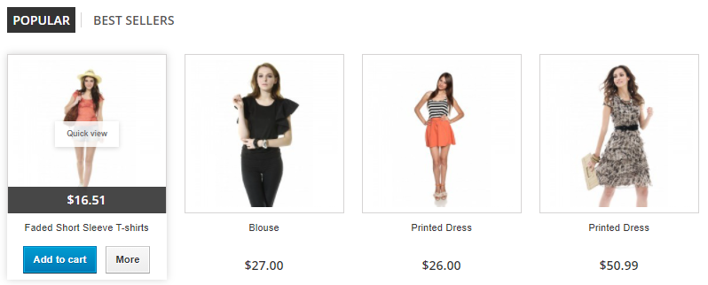

//To check the Best Seller tab w.findElement(By.*xpath*("/html[1]/body[1]/div[1]/div[2]/div[1]/div[2]/div[1]/ul[1]/li[2]/a[1]")).click();

**To test the functionality of “Top Trends”**



//To check The Top trends

w.findElement(By.*xpath*("/html[1]/body[1]/div[1]/div[2]/div[1]/div[2]/div[1]/div[2]/div[1]/ul[1]/li[1]/a[1]/img[1]")).click();

w.navigate().back();

**To test the functionality of “Newsletter”**

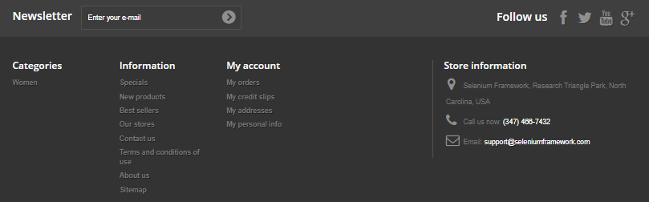

//To check the newslatter tab

w.findElement(By.*id*("newsletter-input")).sendKeys("mystore@test.com");

w.findElement(By.*name*("submitNewsletter")).click();

w.navigate().back();

**To test the functionality of “Best sellers”**



//to check best Seller

w.findElement(By.*xpath*("/html[1]/body[1]/div[1]/div[3]/footer[1]/div[1]/section[3]/ul[1]/li[2]/a[1]")).click();

**To test the functionality of “My account”**



//to check My Account section

w.findElement(By.*xpath*("/html[1]/body[1]/div[1]/div[3]/footer[1]/div[1]/section[5]/div[1]/ul[1]/li[1]/a[1]")).click();

//Login

w.findElement(By.*id*("email")).sendKeys("vsoft1120@test.com");

w.findElement(By.*id*("passwd")).sendKeys("vosft1212");

w.findElement(By.*id*("SubmitLogin")).click();

**To test the functionality of “My account page”**

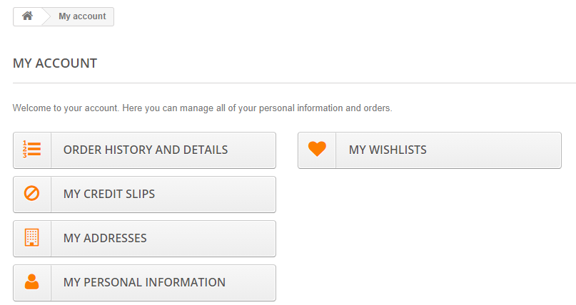

//click to check my wishlist

w.findElement(By.*xpath*("/html[1]/body[1]/div[1]/div[2]/div[1]/div[3]/div[1]/div[1]/div[2]/ul[1]/li[1]/a[1]/span[1]")).click();

**To test the functionality of “My wishlist”**

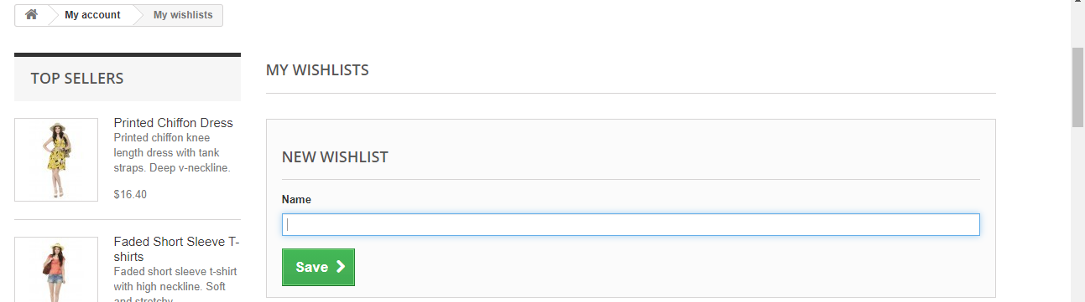

//to add item in wish list

w.findElement(By.*id*("name")).sendKeys("Printed Chiffon Dress");

w.findElement(By.*id*("submitWishlist")).click();

w.findElement(By.*xpath*("/html[1]/body[1]/div[1]/div[2]/div[1]/div[3]/div[2]/div[1]/ul[1]/li[1]/a[1]/span[1]")).click();

//back to home

w.findElement(By.*xpath*("/html[1]/body[1]/div[1]/div[2]/div[1]/div[3]/div[1]/ul[1]/li[1]/a[1]/span[1]")).click();